Capital Regional District
What We Heard Summary Report:
Regional Workshop: Collaborative Action to Resolve Boat-Related
Issues in the Capital Region
Capital Regional District | July 2024

The following provides a “What We Heard” summary report from the CRD’s Regional Workshop: Collaborative Action to Resolve Boat-Related Issues in the Capital Region held on
April 30, 2024.

Table of Contents
Introduction 2
Workshop Overview 2
Local Government Options 3
Overarching Themes 5
Theme 1: Cumulative Environmental Effects 5
Theme 2: Diverse Community Needs and Housing Considerations 5
Theme 3: Enforcement and Capacity Issues 7
Theme 4: First Nations Perspectives and Priorities 8
Theme 5: Advocacy and Coast-wide Solutions 9
Theme 6: Collaboration 10
Opportunities to Move Forward 11
Challenges to Moving Forward 13
Conclusion 13
Appendix A – Agenda and Supporting Documents 15
Appendix B – Presentation Slides 34
Appendix C – April 30, 2024 Meeting Notes 49

Introduction
The unregulated placement of private mooring buoys (PMBs) and proliferation of long-term moored boats, along with an increase in derelict, abandoned and wrecked boats in many bays and harbours throughout the region, have become problematic for several municipalities.
At the January 17, 2024 meeting, Capital Regional District (CRD) staff provided a report to the CRD Board outlining the scope of this issue and provided options for regulation of PMBs that are within the scope of local government control for consideration. The Board directed staff to host a regional workshop to discuss these options and determine if a coordinated strategy is needed.
The CRD Regional Workshop: Collaborative Action to Resolve Boat-Related Issues in the Capital Region, held on April 30, 2024, brought together First Nations, municipal staff, elected officials as well as provincial government staff to review options to reduce or eliminate issues associated with a proliferation of boats and unregulated placement of PMBs in the capital region.
The workshop aimed to meet the following goals:
Goal 1 | Discuss the proposed local government options to determine if a coordinated strategy is needed,
Goal 2 | Determine appropriate locations to address the apparent need for long-term boat storage, and
Goal 3 | Identify opportunities for regional advocacy to provincial and federal governments to assist local government in providing resolution to ongoing boat issues in the region.

The workshop was hosted virtually and in person by the CRD and was attended by 57 local government, First Nations, and provincial staff and council members. A package of information was provided to all participants in advance of the workshop (Appendix A). This report provides an overview of the workshop, local government options considered, highlights six themes that emerged and considers possible next steps.

Workshop Overview
To ensure workshop attendees had a thorough understanding of the boat-related issues and their complexity, CRD staff outlined the scope and scale of boat-related issues in the Capital Region and described the impacts on our coastal communities. Islands Trust staff then emphasized the further complexity of boat-related issues with the intersection of the housing crisis that currently persists on many of the Gulf Islands, particularly Salt Spring Island. CRD staff summarized the jurisdiction, interests, and roles of First Nations, federal and provincial agencies, and local governments, followed by an overview of the federal, provincial and local government legislation and policy tools that are, or could be used, to resolve many of these issues. This included a more in-depth look at specific regulations pertaining to PMBs and wrecked, abandoned and hazardous vessels. Presentation materials can be found in Appendix B.
The remainder of the workshop was discussion-based. Attendees went into small breakout groups to have focused conversations on the benefits and challenges of three proposed local government options for regulating boat-related issues, and group facilitators reported out on the conversations. The workshop concluded with a large group discussion on the key issues, with a focus on collaborative action and possible next steps. Notes from these discussions are summarized in Appendix C.

Local Government Options
Through zoning, land use and structure bylaws, local governments can better manage boat-related use of lands within their metes and bounds by regulating the placement and number of PMBs and regulating the structures associated with the PMBs and regulating uses (e.g., liveaboard, boat storage). Doing so would reduce the need for local governments to respond to incidents of derelict, abandoned and wrecked boats and could address many of the environmental, safety and neighbourhood concerns expressed by the impacted communities.
Three options for PMB regulation that are fully within local government control were presented and examples of successful implementation by other local governments in British Columbia were provided.
These options were:
Option 1 | Prohibit public mooring buoys (PMBs) through zoning and land use bylaws
Option 2 | Regulate allowable harbour uses, the number of and placement of PMBs and allowable structures through zoning, land use and structure bylaws
Option 3 | Allow PMBs and charge a fee through Licence of Occupation (LOO)

In small breakout groups, workshop attendees discussed the benefits and challenges of each option and reported their findings back to the larger group. A brief synopsis of the benefits and challenges for each option is provided in Table 1; full notes from small breakout group discussions can be found in Appendix C.
Table 1. Benefits and challenges of three local government options to regulate
private mooring buoys (PMBs)
 | Benefits | Challenges
Option 1  Prohibit PMBs through Zoning, Land Use and Structure Bylaws | - ‘Simple’ blanket approach to enforcement | - Restriction does not address the foundational issues  - Housing/displacement of liveaboards  - Potential increase in anchoring (damage to seafloor)
Option 2  Regulate PMBs through Zoning, Land Use and Structure Bylaws | - Flexibility: would allow areas of protection while allowing boats and better reflect community needs  - Bylaws/zoning - familiar tools for local governments | - Communication: working between varied groups/governments  - No clear path to funding  - Liability: structure bylaws could affect existing vessels  - Infrastructure and support services
Option 3  Enter into a Licence of Occupation with the Province to Regulate PMBs and Recover Fees | - Revenue, and potential for cost neutral  - Public perception: user-pay a more ‘fair’ option | - Legal/liability concerns, including contamination, unknown risks, First Nation rights and title  - Communication/collaboration - LOO taken out by CRD or Islands Trust?  - Enforcement/collection  - Adaptability - less flexible for local governments

While benefits and challenges were identified with all three options, it was clear that the diverse community needs and varied magnitude of boats and PMBs in the different harbour areas will require a flexible yet consistent approach across the region.
Option 1 received the least support, while Options 2 and 3 received higher support due to the increased flexibility and ability to establish a more consistent regional approach. Funding and capacity for enforcement and provision of services was a significant concern for all options. The ability to charge fees to recover costs through a LOO under Option 3 was desirable; however, substantial apprehension regarding the potential transfer of liability to local governments due to clauses within the LOO agreement outweigh the ability to collect fees for some local governments. None of the options resolved the foundational and underlying issues driving the proliferation of boat communities and moorage areas throughout the region.

Overarching Themes

Theme 1: Cumulative Environmental Effects
The environmental issues caused by deregulation and the subsequent proliferation of PMBs and the corresponding increase in abandoned and wrecked boats in the capital region were undisputed during this workshop.
Impact on these ecosystems, particularly in terms of cumulative effects, was central to the sense of urgency and scale surrounding the issue. It was also noted that cumulative effects are a relatively new consideration in some provincial and federal legislation and need to be considered in relation to issues around proliferations of PMBs and boats/structures. This means that environmental impacts and certain supporting documentation, especially in terms of surveys and studies related to PMBs and liveaboards, may be required.
All represented communities had a strong desire for change, and the ‘complexity’ and ‘challenges’ which were the focal points of discussions were not seen as insurmountable compared to the desire to better protect these important coastal environments.
“At what concentration of these so-called minor works does it stop being minor?”
“We have to commit to do this together, we have to do it sooner rather than later”

Theme 2: Diverse Community Needs and Housing Considerations
Recognition of diverse community needs and impacts, housing considerations and the desire for flexibility and adaptability within the regulatory options in affected harbour areas were prominent themes throughout the discussions. Staff presentations highlighted how interwoven the proliferation of PMBs, boats/structures and liveaboards are with the accessible and affordable housing crisis, especially on Salt Spring Island. Both the effect and public fallout that all options would have on these communities was top of mind and one of the leading reasons that Option 1 was considered, by many, to be insufficient.
The ubiquitous nature of PMBs and boat/structure proliferation, intersections with housing and other social issues, lack of dock space to moor boats across the region, and potential impact of action in one area or another (i.e., moving the problem around) featured prominently in the discussions. It was stressed that consideration of regulatory impacts must be involved in all stages of planning and implementation of any potential solutions.
In the areas of the region affected by this issue, there exists a significant disparity in scale: compare 138 boats in Ganges Harbours with 23 boats in the entirety of the Sooke Basin. Those areas with over 100 PMBs and boats/structures (such as Ganges Harbour, Brentwood Bay and Tsehum Harbour) most often lack the amenities and services required for these floating communities (pump out facilities, showers, garbage disposal and recycling, shore-based dinghy tie-up and access points). This often contributes to the complaints expressed by the surrounding communities impacted by dumping of garbage and sewage, trespassing on private and public property, shore areas taken up by dinghies, and concerns for the environment. Most of the local governments are funding and resource challenged, leading to an inability to provide needed services. On the Gulf Islands, while the Islands Trust is responsible for land use and planning, the CRD or Improvement Districts are responsible for provision of sewage treatment and drinking water facilities and services, which further complicates the matter. The potential role of marinas in provision of some services and amenities was also discussed.
“The people who live on these boats are also members of our community – many of them contribute economically and socially to community life.”
“The housing dilemma, it’s not just a matter of cleaning up garbage, the human side of this matters… Figuring out where people can go is not something that the local government can do alone.”

Each affected harbour area has differing issues, community needs, resources and services, therefore, individual local governments and First Nations communities need to define their desired outcomes and what they wish to achieve in their areas of jurisdiction and interest (i.e., do they want to provide for and manage PMBs and related boats, do they want to recover costs, do they want to/need to provide associated shore services, what level of protections are needed for key environmental and cultural features). This will help to inform regional actions and direction.
When confronted with this challenge, many advocated for a solution centered on research and representation. For instance, the development of resources aimed at better understanding community needs, such as an inventory of liveaboard boaters. Workshop participants sought solutions that were scalable to the unique requirements of their communities and their diverse needs.
Local government staff in the region could collaboratively develop model land use, structure and zoning bylaw language. Over the short-term, a collaborative approach from a place of local government control is likely to achieve improvements more quickly than awaiting the results of advocacy to the provincial and federal governments.
“These issues are harbour dependant and site specific. [Thus] a one size fits all approach would not be appropriate.”
“Comparing Salt Spring with Port Renfrew… some harbours have more active problem areas than others…rather than try to tackle it all at once, work with problem areas [first] and apply solutions gleaned from problematic areas.”

Theme 3: Enforcement and Capacity Issues
The ongoing challenges of staff capacity and funding, along with enforcement capacity constraints and multi-jurisdictional complexities of enforcement, was a dominant theme in all workshop discussions and was expressed by all levels of government and First Nations representatives.
The federal government is largely responsible for the regulation of PMBs, yet enforcement of PMBs from Transport Canada staff’s perspective is limited to their proximity to navigation channels and other PMBs or compliance with colour, size and markings of the buoys as per the PMB regulations and Minor Works Order. Transport Canada and Coast Guard staff also struggle with a lack capacity and resources, hampering their ability to enforce compliance with Minor Works Order and PMB regulations. The federal government is also responsible for boat safety, wrecked, abandoned and hazardous vessels, navigation, migratory bird sanctuaries and protection of fish habitat.
The Province, on the other hand, has chosen not to regulate the placement of PMBs on provincial seabed, despite its ability to do so and its deference to federal authority is problematic for local governments and coastal communities. Lack of capacity and the small footprint of PMB anchor blocks were cited as the main reasons that the Province’s Policy on Private Moorage purposefully excludes PMBs; however, cumulative effects of large proliferations of PMBs and boats must be considered.
Local government staff across the region expressed lack of staff capacity and funding as key constraints in taking any action. Enforcement action of PMBs, and the associated boats and structures, and the requirement to post notices on vessels to have them declared wrecked, abandoned or hazardous is further limited by their lack of access to a boat. Proliferation of floating communities and the lack of regulation in appropriate uses has also led to an increased need for policing and fire services in some areas. In certain instances, staff were directed not to enforce existing bylaws due to housing issues.
As concerns surfaced regarding the adequacy of current enforcement mechanisms, it became evident that each stakeholder had distinct roles and enforcement jurisdictions. Each local, provincial and federal agency is responsible for different aspects of what needs to be enforced in problem areas and there is little coordination between agencies, although attempts to coordinate enforcement have been made.
Regular and collaborative enforcement among all levels of government would enable cross-jurisdictional compliance with all levels of regulation and was an approach that workshop participants thought should be considered. Many participants stressed that effective enforcement of PMB, boat and land use regulations would require working across a diverse group of stakeholders in all facets of planning and implementation, especially as it concerned issues of funding, enforcement and administration required by the three PMB options.
Examining successful PMB regulation models in communities such as the City of Victoria and Manion Bay demonstrated that initial investments in enforcement yielded rapid returns, with enforcement demands diminishing as community adherence solidified. While there were no easy answers to where these resources could come from, defining enforcement as a key constraint was an important part of discussion.
Participants emphasized the need for collaborative efforts to overcome these capacity issues and ensure effective enforcement measures are implemented.
“All three options are great, but the costs associated and the burden of that is really hard, [and] would fall most heavily to municipalities”

“It’s water-world out there… regulation without enforcement will not work”

Theme 4: First Nations Perspectives and Priorities
A recurring theme in group discussions was the significance of incorporating First Nations perspectives and priorities when addressing these issues. During breakout sessions, participants raised questions concerning how the regulation or restriction of PMBs would impact First Nations' rights and title, as well as their access to cultural and harvesting sites.
First Nations representatives at the workshop wanted to ensure meaningful participation and respect for their interests, including hunting and fishing rights, cultural practices and self-governance.
Discussions also emphasized the evolving role of First Nations, particularly concerning coastal areas. Through the provincial Coastal Marine Strategy, the role of First Nations regarding the seabed and marine environment may evolve. This discussion underscored the importance of collaboration and relationship-building with First Nations communities. Participants agreed that any actions moving forward to address boat related issues need to include First Nations.
“We know it’s not just about harvesting, it’s not just about access, we know it’s also about degradation to cultural sites. We know its also about not respecting the ancestors.”
“These ideas need to be brought to different indigenous groups sooner than later so they can discuss what parts they want to participate in and what actions need to be taken.”

Theme 5: Advocacy and Coast-wide Solutions
In 2023, there were an estimated 1,185 private mooring buoys and 862 boats and structures creating floating communities and floating moorage areas throughout 21 bays and harbours in the capital region. A review of orthophotos in 1996, 2005, 2013 and 2023 revealed a significant increase in PMBs with attached boats or other structures following transfer of authority from Fisheries and Oceans Canada (DFO) to Transport Canada, and subsequent inclusion of PMBs as a minor works and removal of authorization requirement in 2009.
Furthermore, the lack of provincial regulation around the placement and use of PMBs on provincial seabed and their deference to federal authority is problematic for local, coastal waters and communities. Workshop participants were clear that the unpermitted and long-term placement of PMBs and associated boats and structures on provincial crown land needs to be regulated by the Province. If a similar situation occurred on terrestrial provincial crown land, the Province would consider it trespassing and would require the trespasser to move on. Advocacy on this is essential to achieving a coast-wide solution. Organizations such as the Association of Vancouver Island Coastal Communities and the Union of BC Municipalities were cited as examples of partner organizations that, if collaborated with, could aid in advocacy efforts.
Given the challenges of capacity, funding, enforcement and liability that restricted the support of Options 2 and 3, workshop participants were resolute that progress on these issues must engage both federal and provincial authorities. As many highlighted, this issue transcends our region - it is coastal in nature, and the engagement of higher levels of government could serve as a catalyst for overcoming the key challenges of this project.
The inventory and regional context highlighted how deregulation at the federal level and lack of regulation at the provincial level has exacerbated a growing problem for coastal communities across this region and coastal British Columbia. The Regional Boats Workshop affirmed the need for ongoing advocacy to federal and provincial agencies to improve PMB regulation, achieve a coast-wide solution, and to move forward with a collaborative approach.
“This is a problem that has been created by deregulation, or the absence of regulation at higher levels of government… so there is a fourth option which includes advocating directly to federal and provincial governments.”
“We’re not the only region, not the only area, dealing with this. It is a coast issue now and we need a coastal solution”

Theme 6: Collaboration
The complex and multi-jurisdictional regulatory framework regarding PMBs, boats and structures, administration and control of the seabed, land use planning and provision of services underscored most discussions. The absolute necessity of collaboration across multiple levels of government and with First Nations was perhaps the strongest theme emerging from the workshop.
In addition to the 13 municipalities and three electoral areas, the capital region’s lands and waters have 19 First Nations with treaty rights and title to shellfish harvesting, fishing and environmental stewardship, as well as four provincial and five federal departments with some level of legislative control or interest.
Many participants noted the jurisdictional complexity detailed above and stressed that effective regulation of PMB would require working across a diverse group of stakeholders in all facets of planning and implementation, especially as it concerned issues of funding, enforcement and administration required by the three PMB options. A working group or ‘task force,’ especially in the planning stages of this work, was proposed as a solution to encourage collaboration and could be utilized to coordinate action.
Workshop participants made it clear that the continued increase in PMBs and boats, and ongoing challenges with capacity and funding, will require timely, collective and coordinated action across the region. The need for federal and provincial leadership in creating a coast-wide solution by enhancing or creating improved policy and legislation around PMBs to assist local governments in dealing with the multiple issues across the coast was also identified as a critical next step. Similarly, the importance of meaningful engagement and consideration of impacts to First Nations rights and title and desire for collaborative solutions should be considered moving forward. A coordinated regional and coastal approach, with significant leadership from the Province, emerged as a crucial framework through which to take next steps.
“I believe the way forward is collaboration, absolutely.’’
“[what is needed is] a coordinated approach with resources behind it to bring a fulsome answer to the table”

Opportunities to Move Forward
Following the workshop, CRD staff reviewed all materials and notes to chart a proposed approach to achieve resolution to boat-related issues in the capital region.

Identification of local government objectives and desired outcomes for each harbour area
This could include:
- identifying important marine habitat and cultural areas that require improved protection
- identifying suitable areas for boat communities and moorage areas
- identifying appropriate uses, zoning and defining structure requirements through appropriate land use, zoning and structures bylaws
- defining needed services/facilities for the defined uses
- engaging with appropriate First Nations communities
- improving enforcement capacity

Coordinated regional action to achieve short term improvements
This could include:
- establishment of a collaborative, regional working group
- meaningful engagement and discussions with First Nations partners to determine their interests and desired level of involvement
- creation of consistent bylaw language pertaining to zoning, uses and structures for PMBs, long-term boat use and liveaboards that can be used by local governments to amend appropriate bylaws
- developing a more rigorous inventory of boats, PMBs and liveaboards
- support for the identification of important habitat and cultural areas, as well as areas suitable for proliferations of boats and PMBs
- obtaining legal input on identified liability and legal concerns
- exploring collaborative enforcement options

Continued advocacy to provincial government for coast-wide solutions
This could include:
- requesting assistance and leadership in developing a longer-term coast-wide solution to provide assistance to local governments in resolving these issues
- bringing motions at Association for Vancouver Island Coastal Communities and Union of BC municipalities requesting that the Province establish a working group or task force
- create funding opportunities to support local governments in resolving issues happening within their metes and bounds
- encouraging improved regulation and policy regarding placement of PMBs on provincial crown land (seabed)

Continued advocacy to federal government
This could include:
- requesting assistance and leadership in developing a longer-term coast-wide solution to provide assistance to local governments in resolving the issues related to the proliferation of PMBs and associated boats/structures in harbour areas
- amending Minor Works Regulation and PMB regulations to include prohibitions around placement in important habitat and cultural areas, such as eel grass habitat, estuary areas, clam harvesting areas and critical habitats
- collaborative enforcement and supporting local governments in realigning PMB locations, as necessary
Advocating to provincial and federal governments for support will take some time and it is anticipated that any legislative improvements will be a longer-term solution. The desire for immediate action and resolution over the short term requires local governments to continue to pursue a solution within local government control. This will enable a faster and more urgent response that can be flexible to meet the needs of each local government and harbour area.
CRD staff suggest that local government staff begin working towards actions 1 and 2 above, while elected officials focus on continued advocacy as outlined in actions 3 and 4 above.

Challenges to Moving Forward
Funding and capacity issues at all levels need to achieve a resolution to move forward with the proposed approaches outlined above. The urgency and continued growth of these issues in this region present ongoing challenges.

Funding and Resourcing
The financial implications of dealing with the growing proliferation of boats and PMBs are potentially significant and continue to impact the ability of all levels of government and First Nations communities to resolve some of these issues. Reliance by all levels of government for another level of government to provide funding and resources to resolve these issues has, in some ways, led to a state of collective inaction. A regional approach would achieve economies of scale and efficiencies by working together; however, appropriate resources and staffing at all levels will be required.
What we heard from workshop participants was that, given the challenges of capacity, funding, enforcement and liability, none of the proposed options were deemed sufficient without corresponding advocacy to and involvement from higher levels of government.

Need for Urgency and Diligence
During the workshop, it was noted how dramatically the context of these issues has changed in the last 10 years, and how rapidly they are continuing to evolve. This emphasizes two crucial points: first, the urgency for action to address a rapidly growing problem in our coastal communities; and second, the imperative to undertake this task diligently. The overwhelming consensus from all workshop discussion was the importance of working collaboratively, drawing from diverse perspectives and grounded in a deep understanding of the multifaceted, jurisdictional complexities defining the issue and moving forward with a sense of urgency and diligence.

Conclusion
The proliferation of long-term moored boats and the corresponding increase in abandoned derelict or wrecked boats are a direct result of the unregulated placement of PMBs. Dealing with derelict, abandoned and wrecked boats requires complex jurisdictional oversight and significant municipal resources. Local governments can control the presence or absence of PMBs within their metes and bounds and need to consider their next steps and, in some cases, need to increase enforcement of existing regulations.
Meaningful progress necessitates local government engagement with federal, provincial and First Nations partners, which includes advocating directly to higher levels of government for support and legislative changes, while also collaborating with local and municipal governments to develop resources and take prompt action. A working group was discussed as a way of facilitating collaboration on next steps, which will include advocacy efforts and resource development.
A coordinated regional and coastal approach emerged as a crucial framework though which to take on next steps. A regionally coordinated approach is also needed to achieve economies of scale, a consistent approach and to avoid moving the problem around the region. Continued and ongoing advocacy to federal and provincial governments for leadership and assistance is also required to navigate the complexities of these issues. However, resolving capacity and funding issues are barriers that must be overcome. It is also vital to ensuring a sustainable future for our coastal communities.
Appendix A – Agenda and Supporting Documents
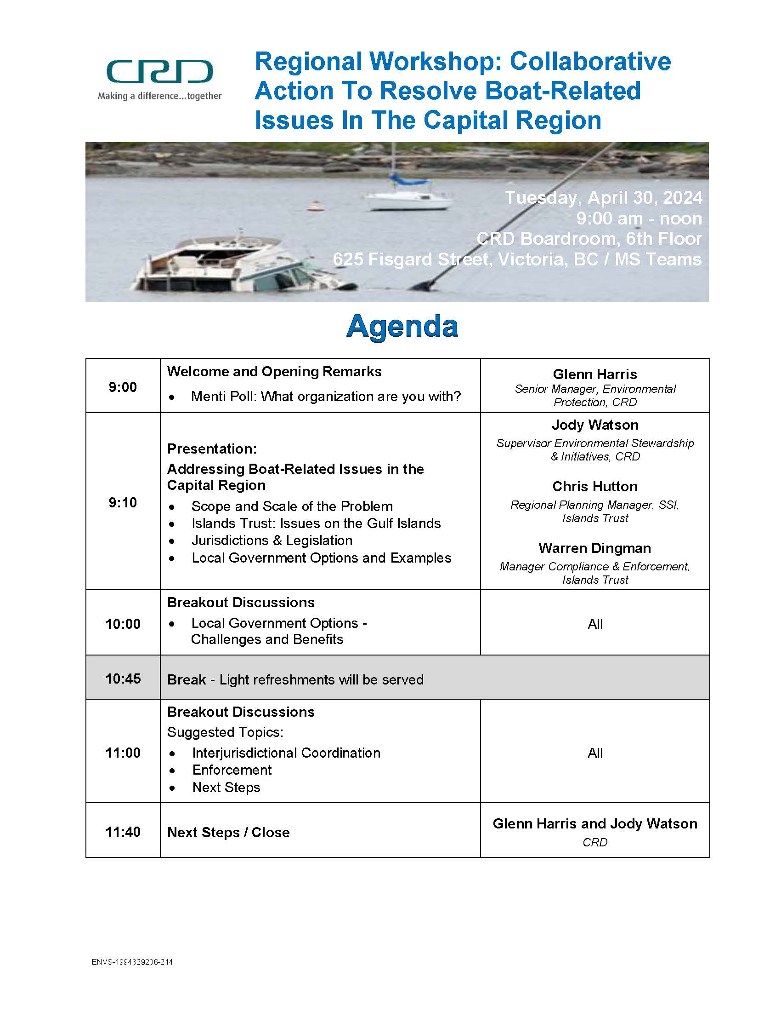
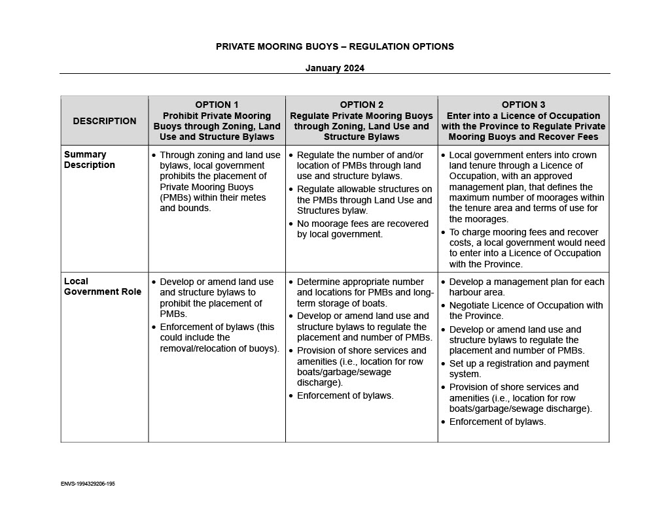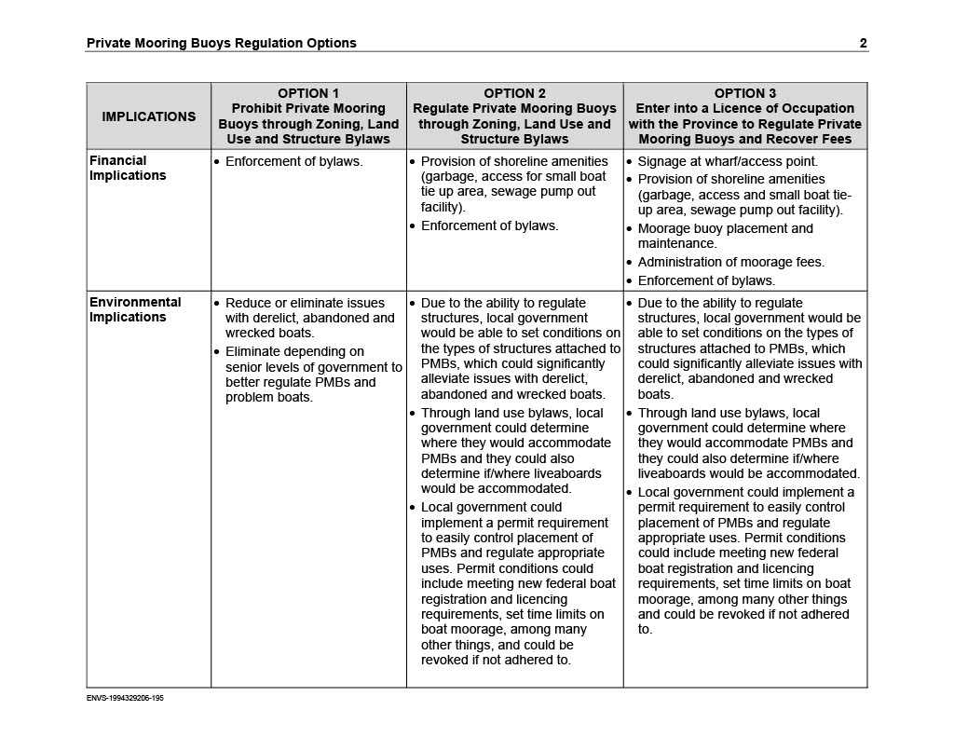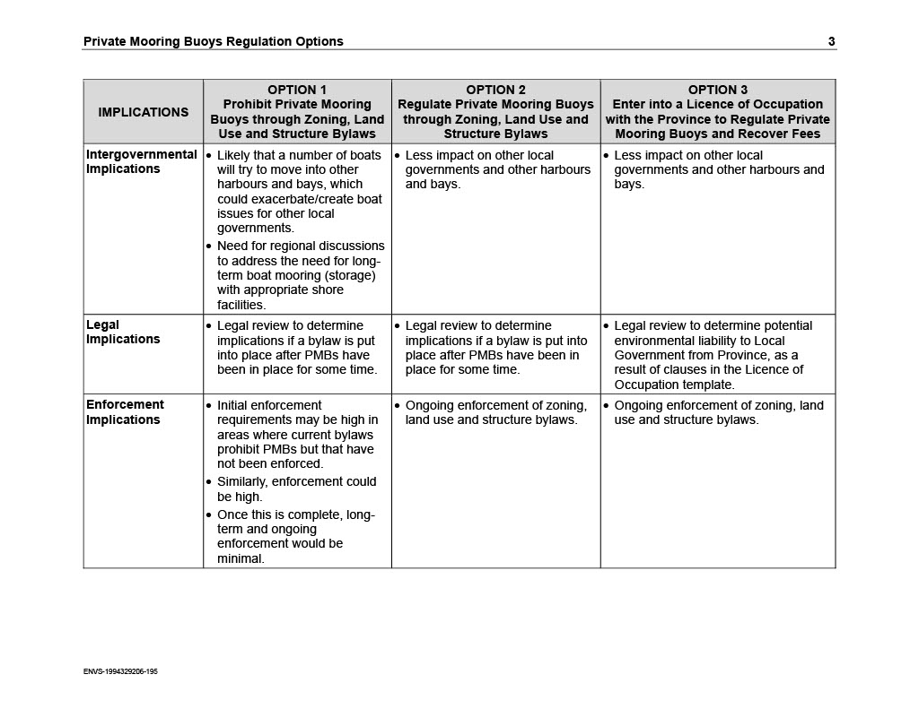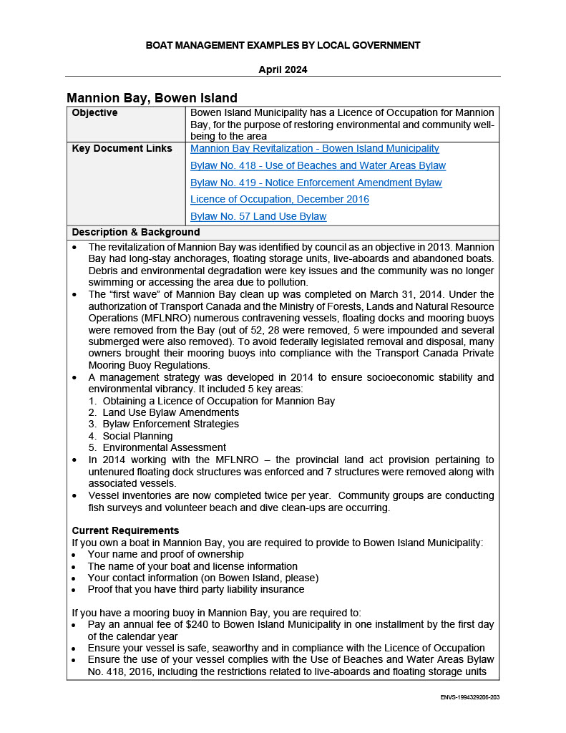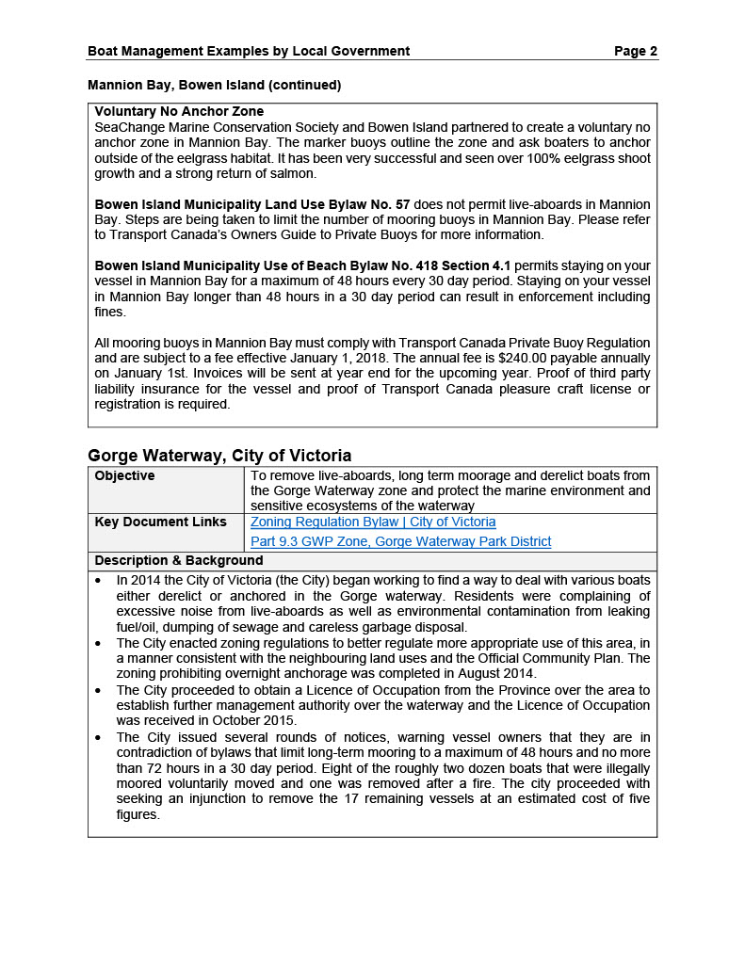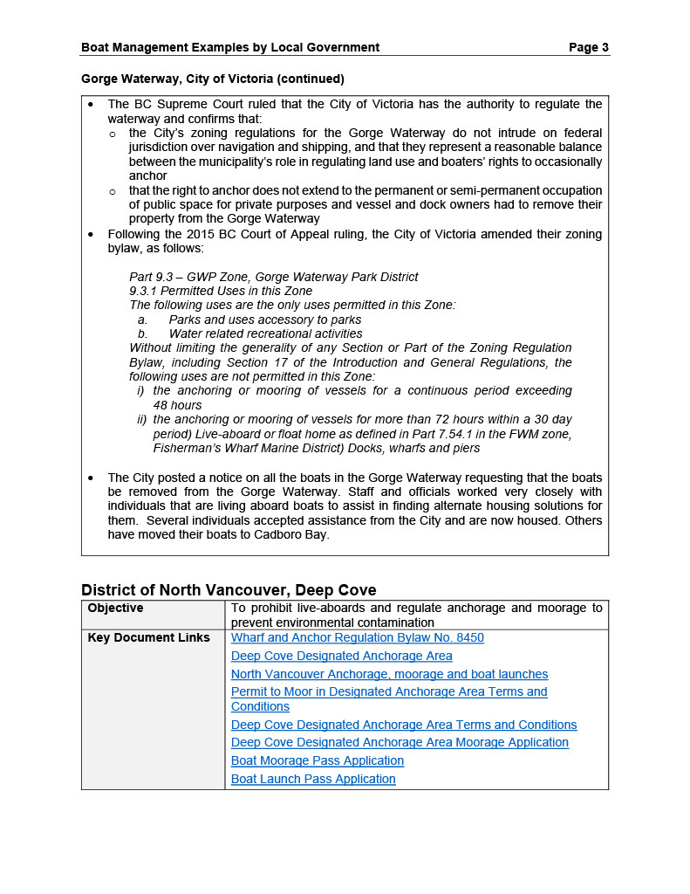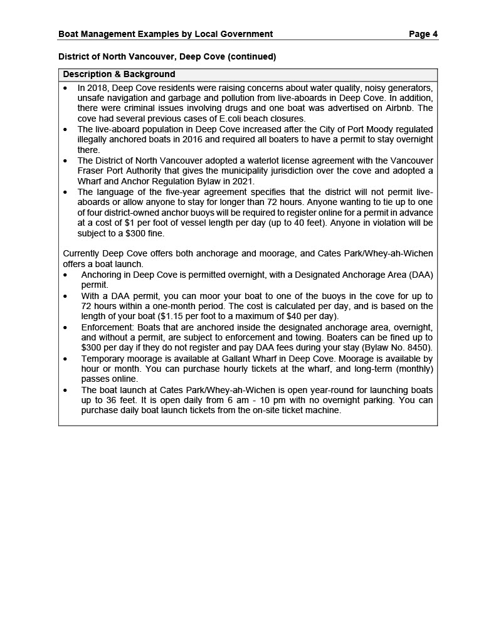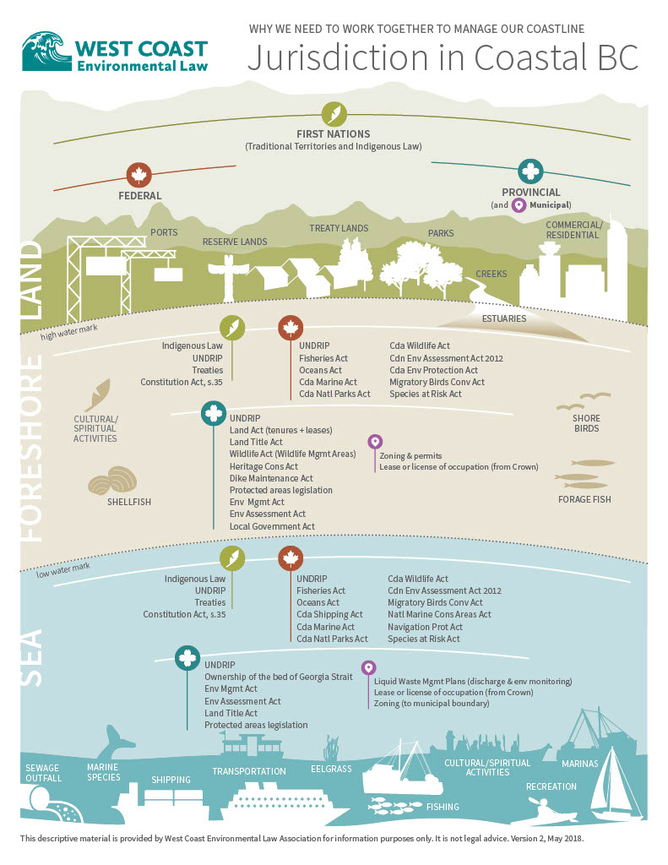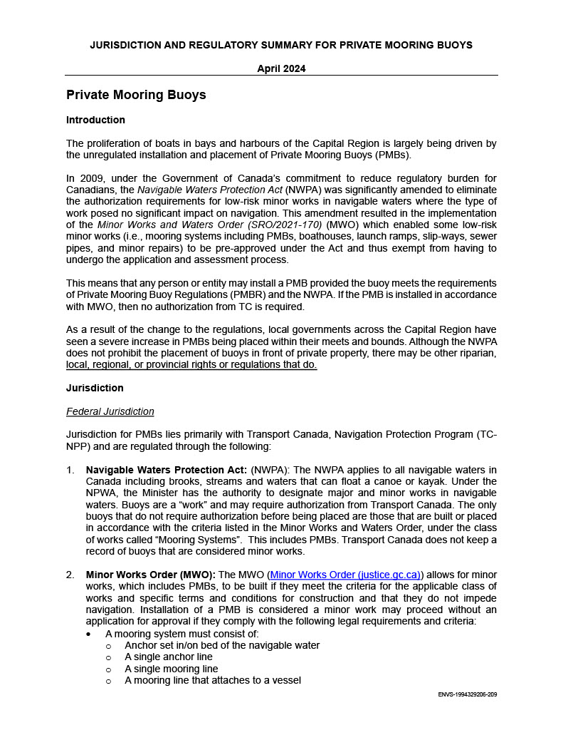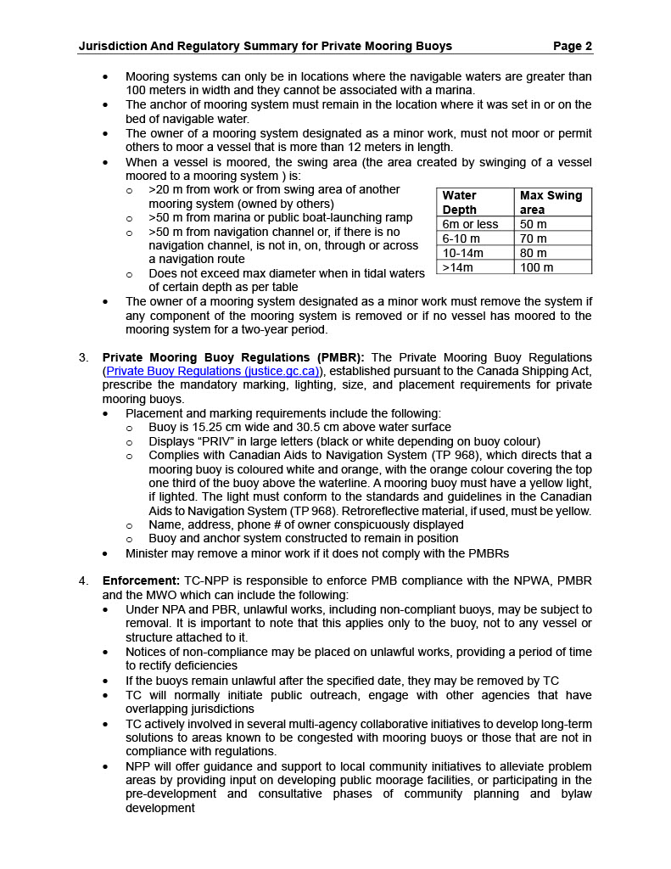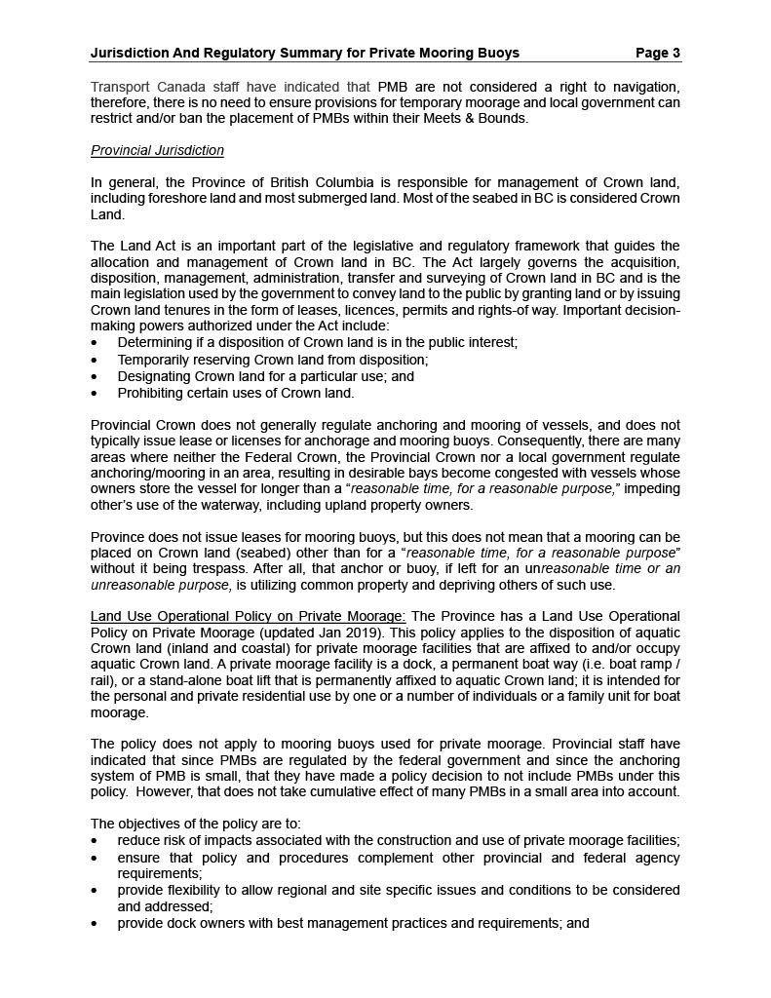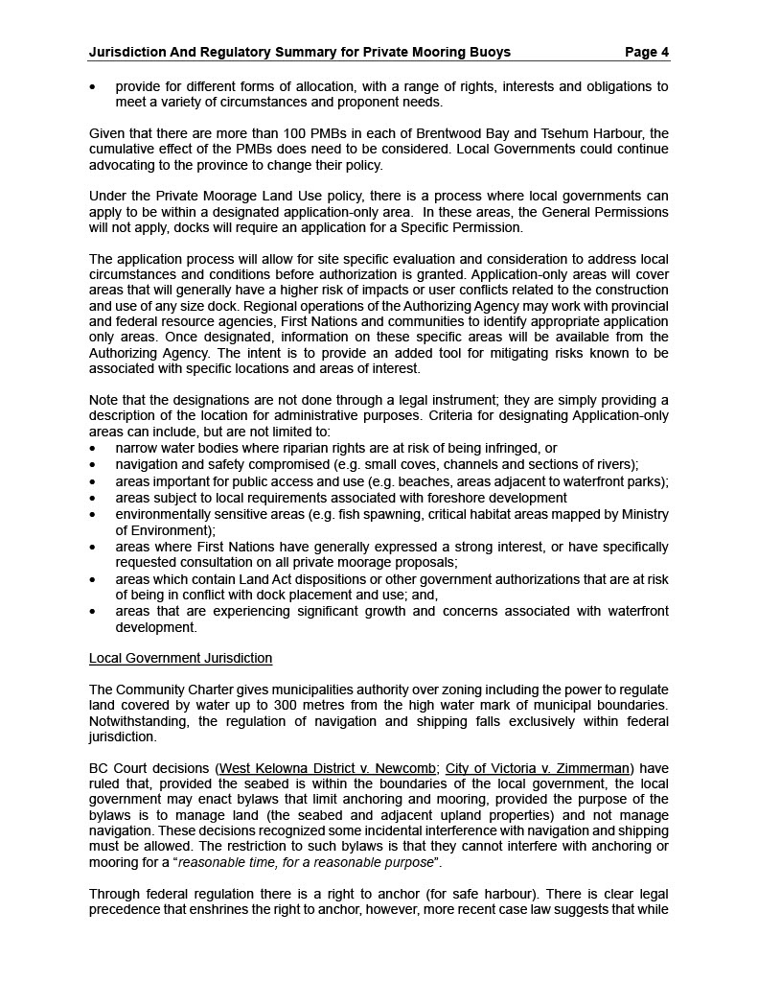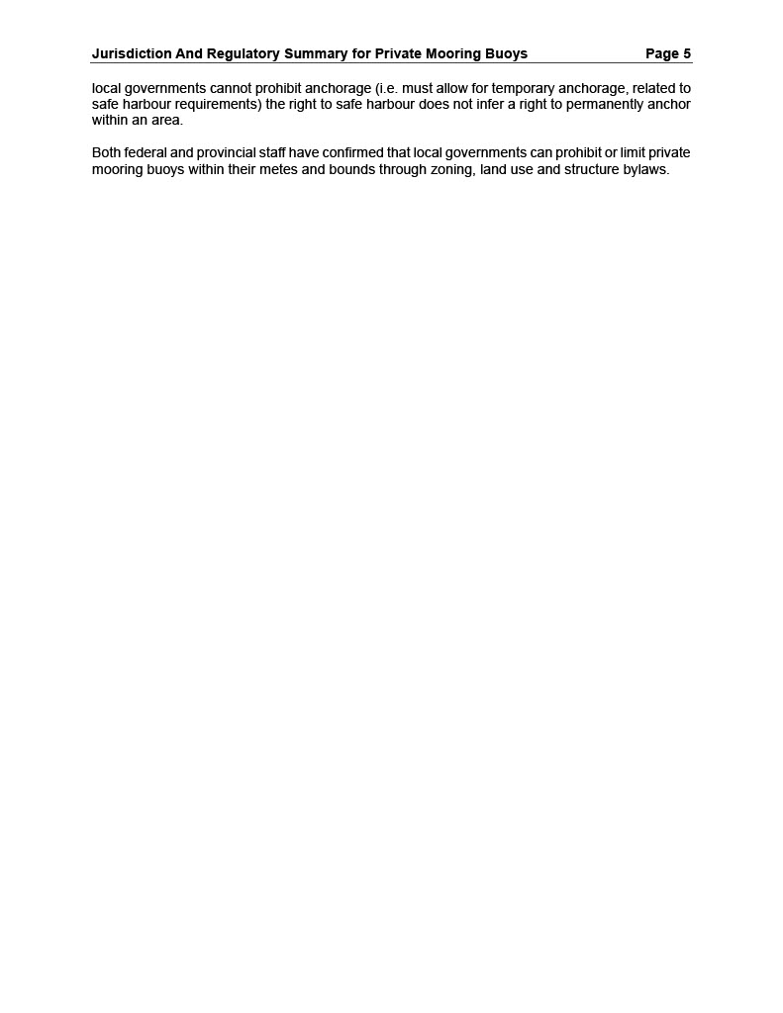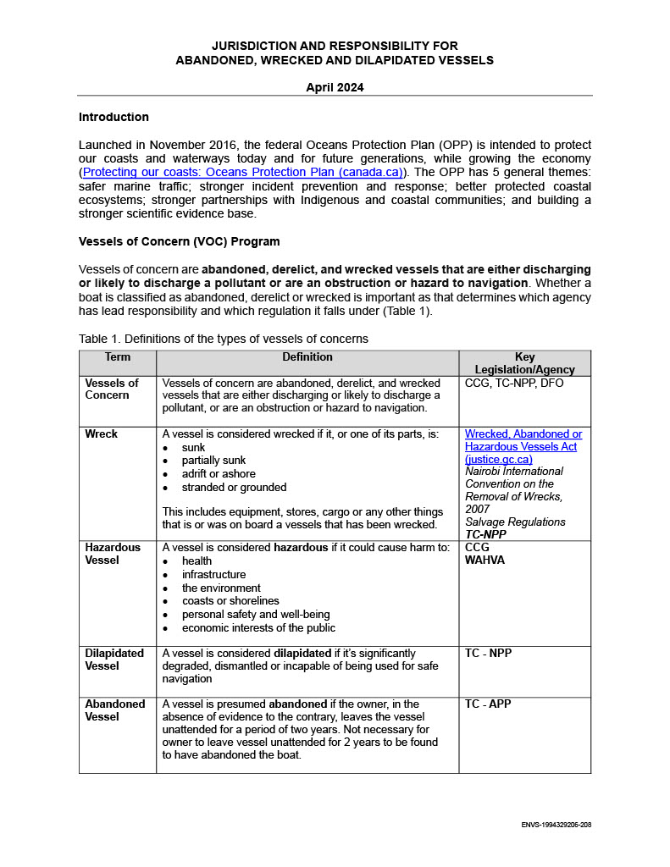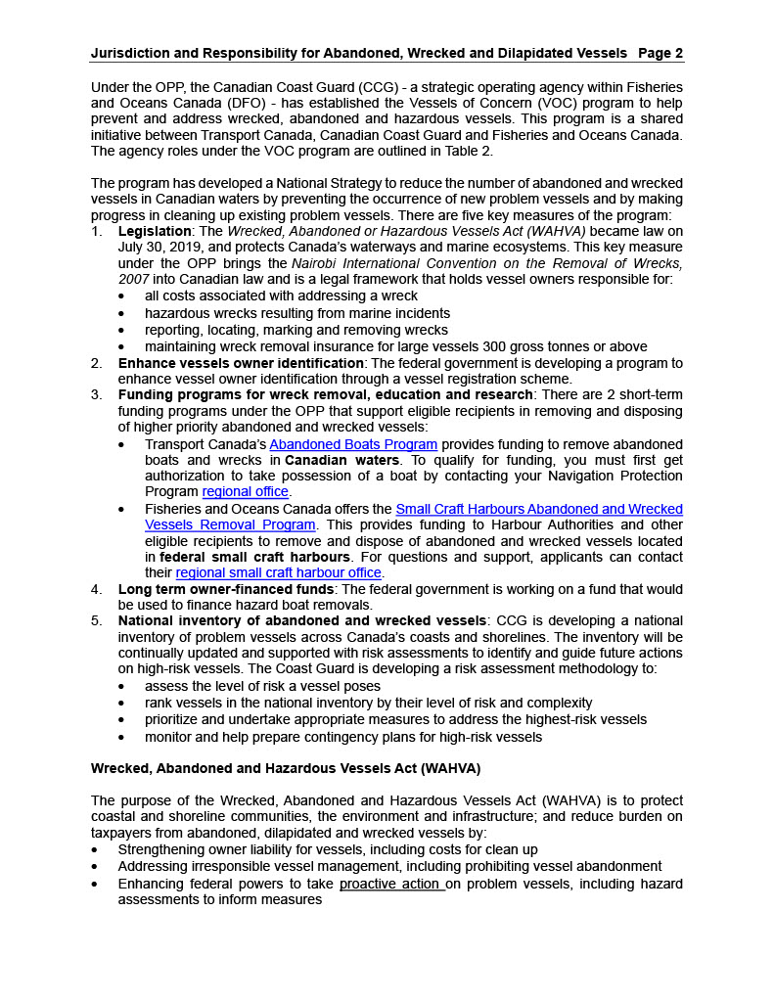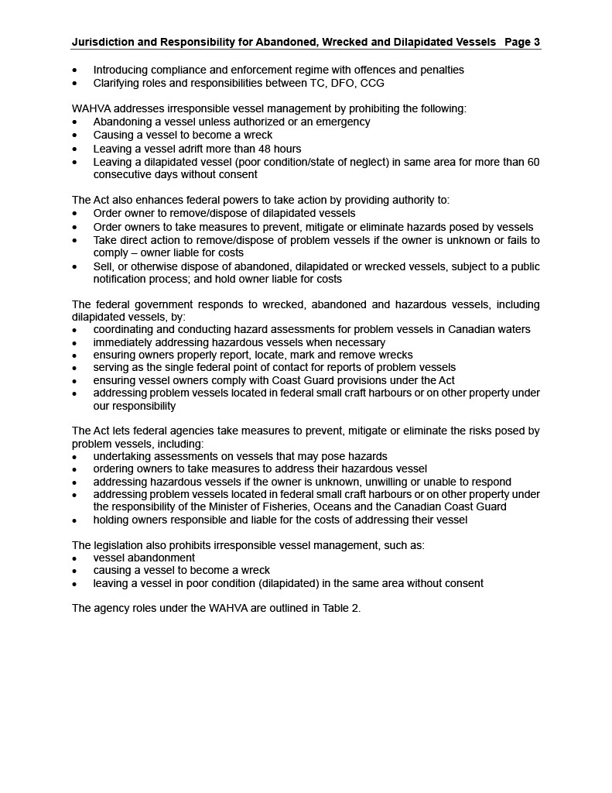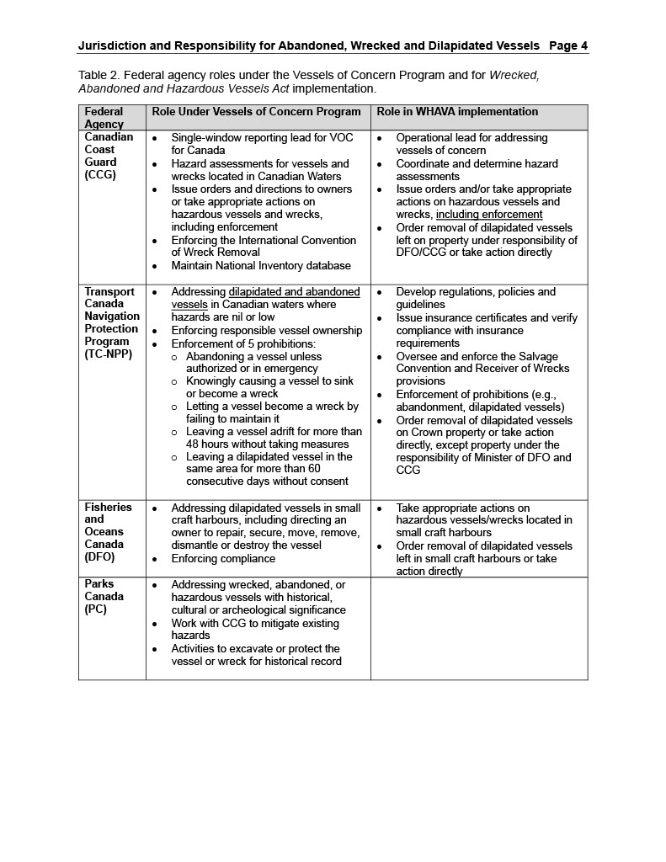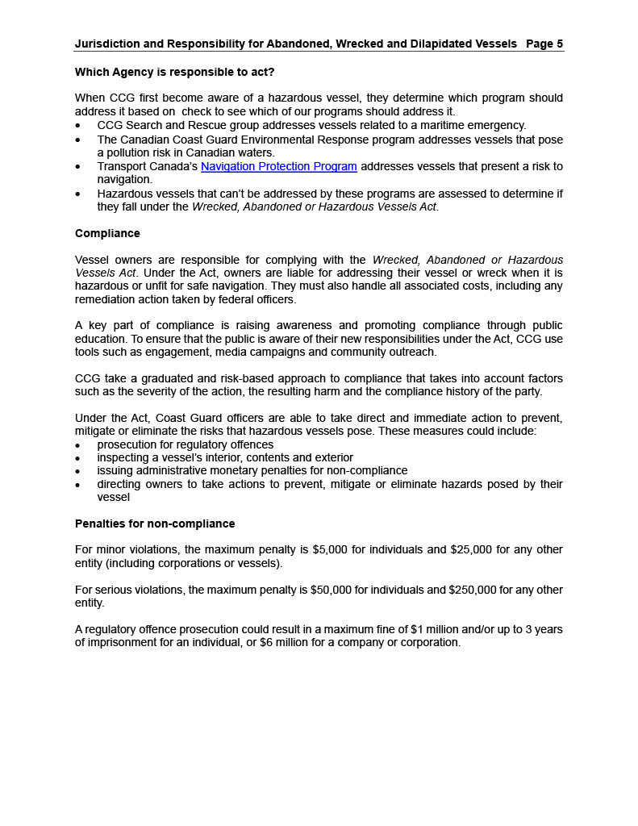

Appendix B – Presentation Slides

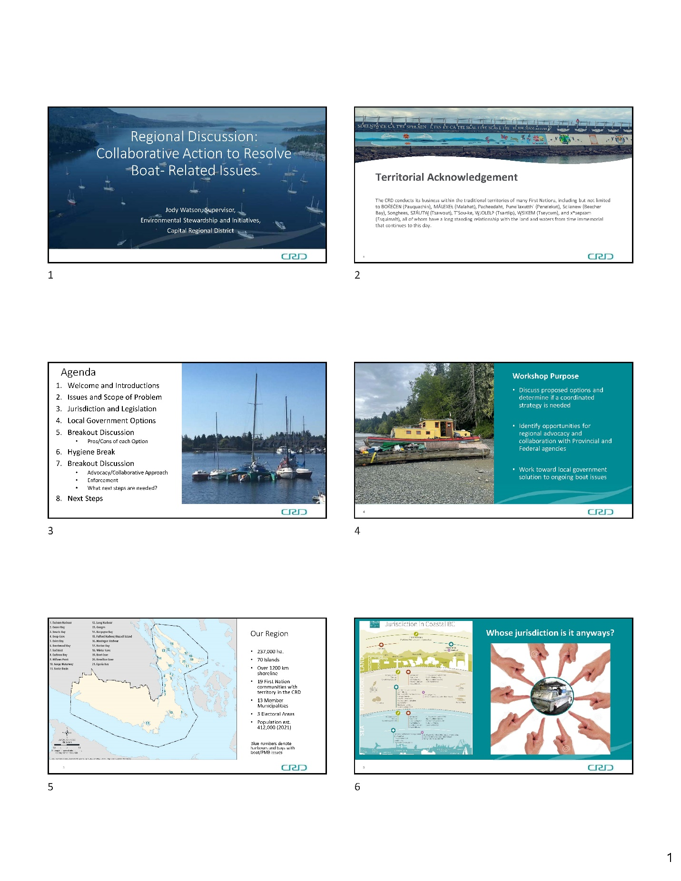

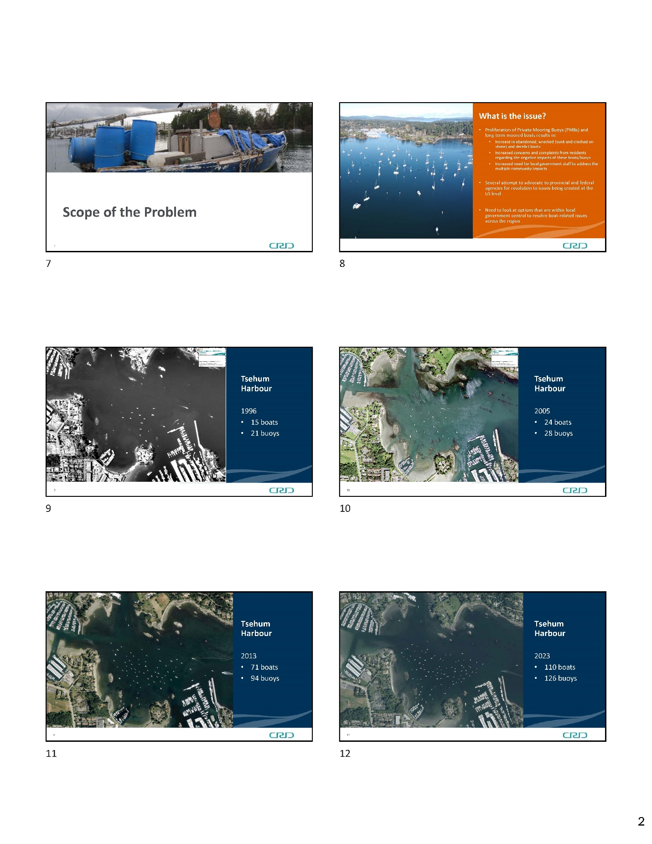
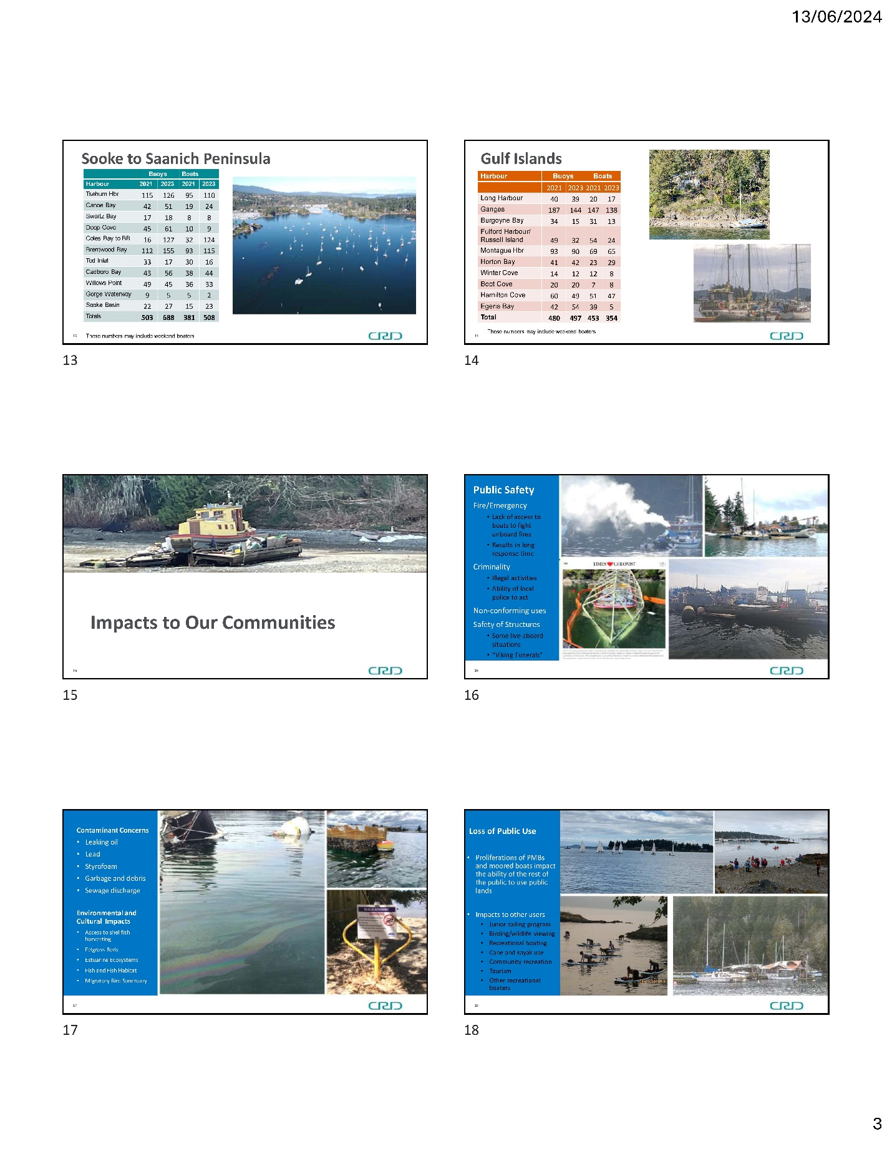

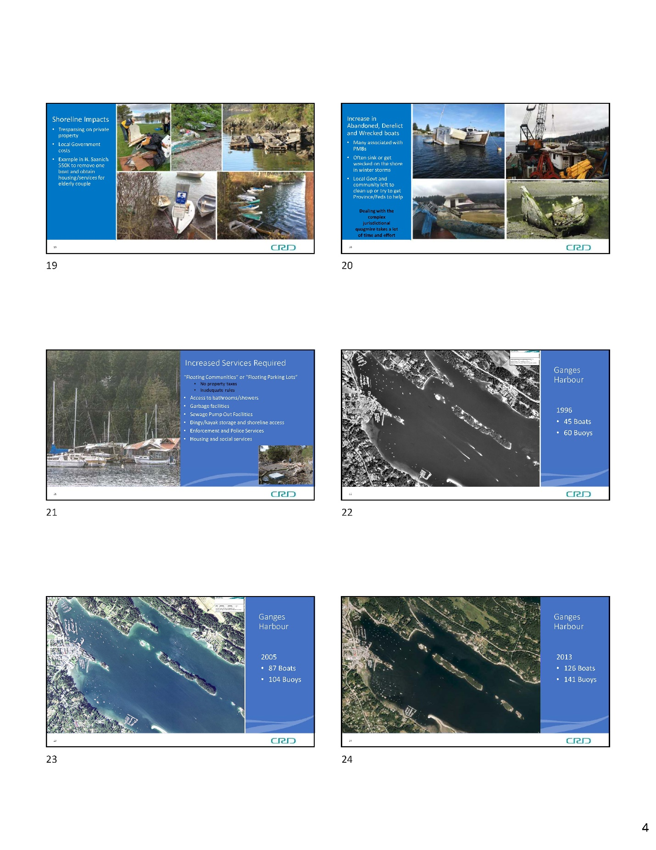
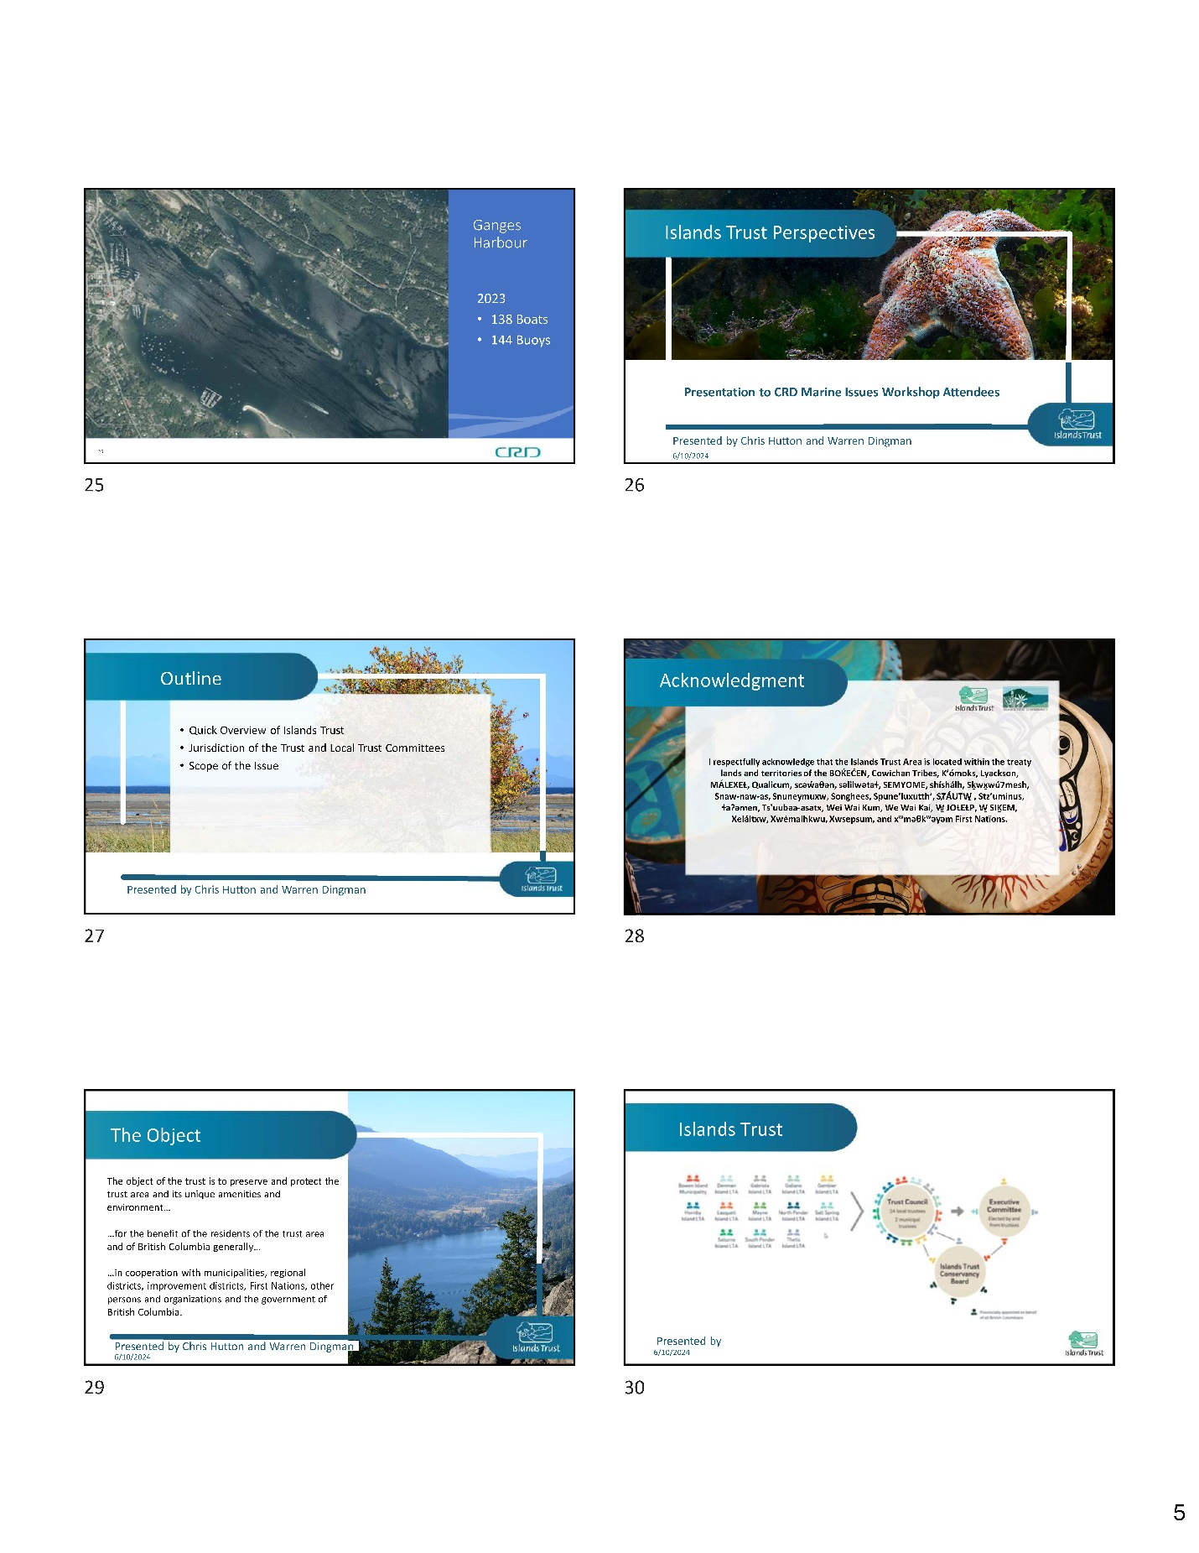
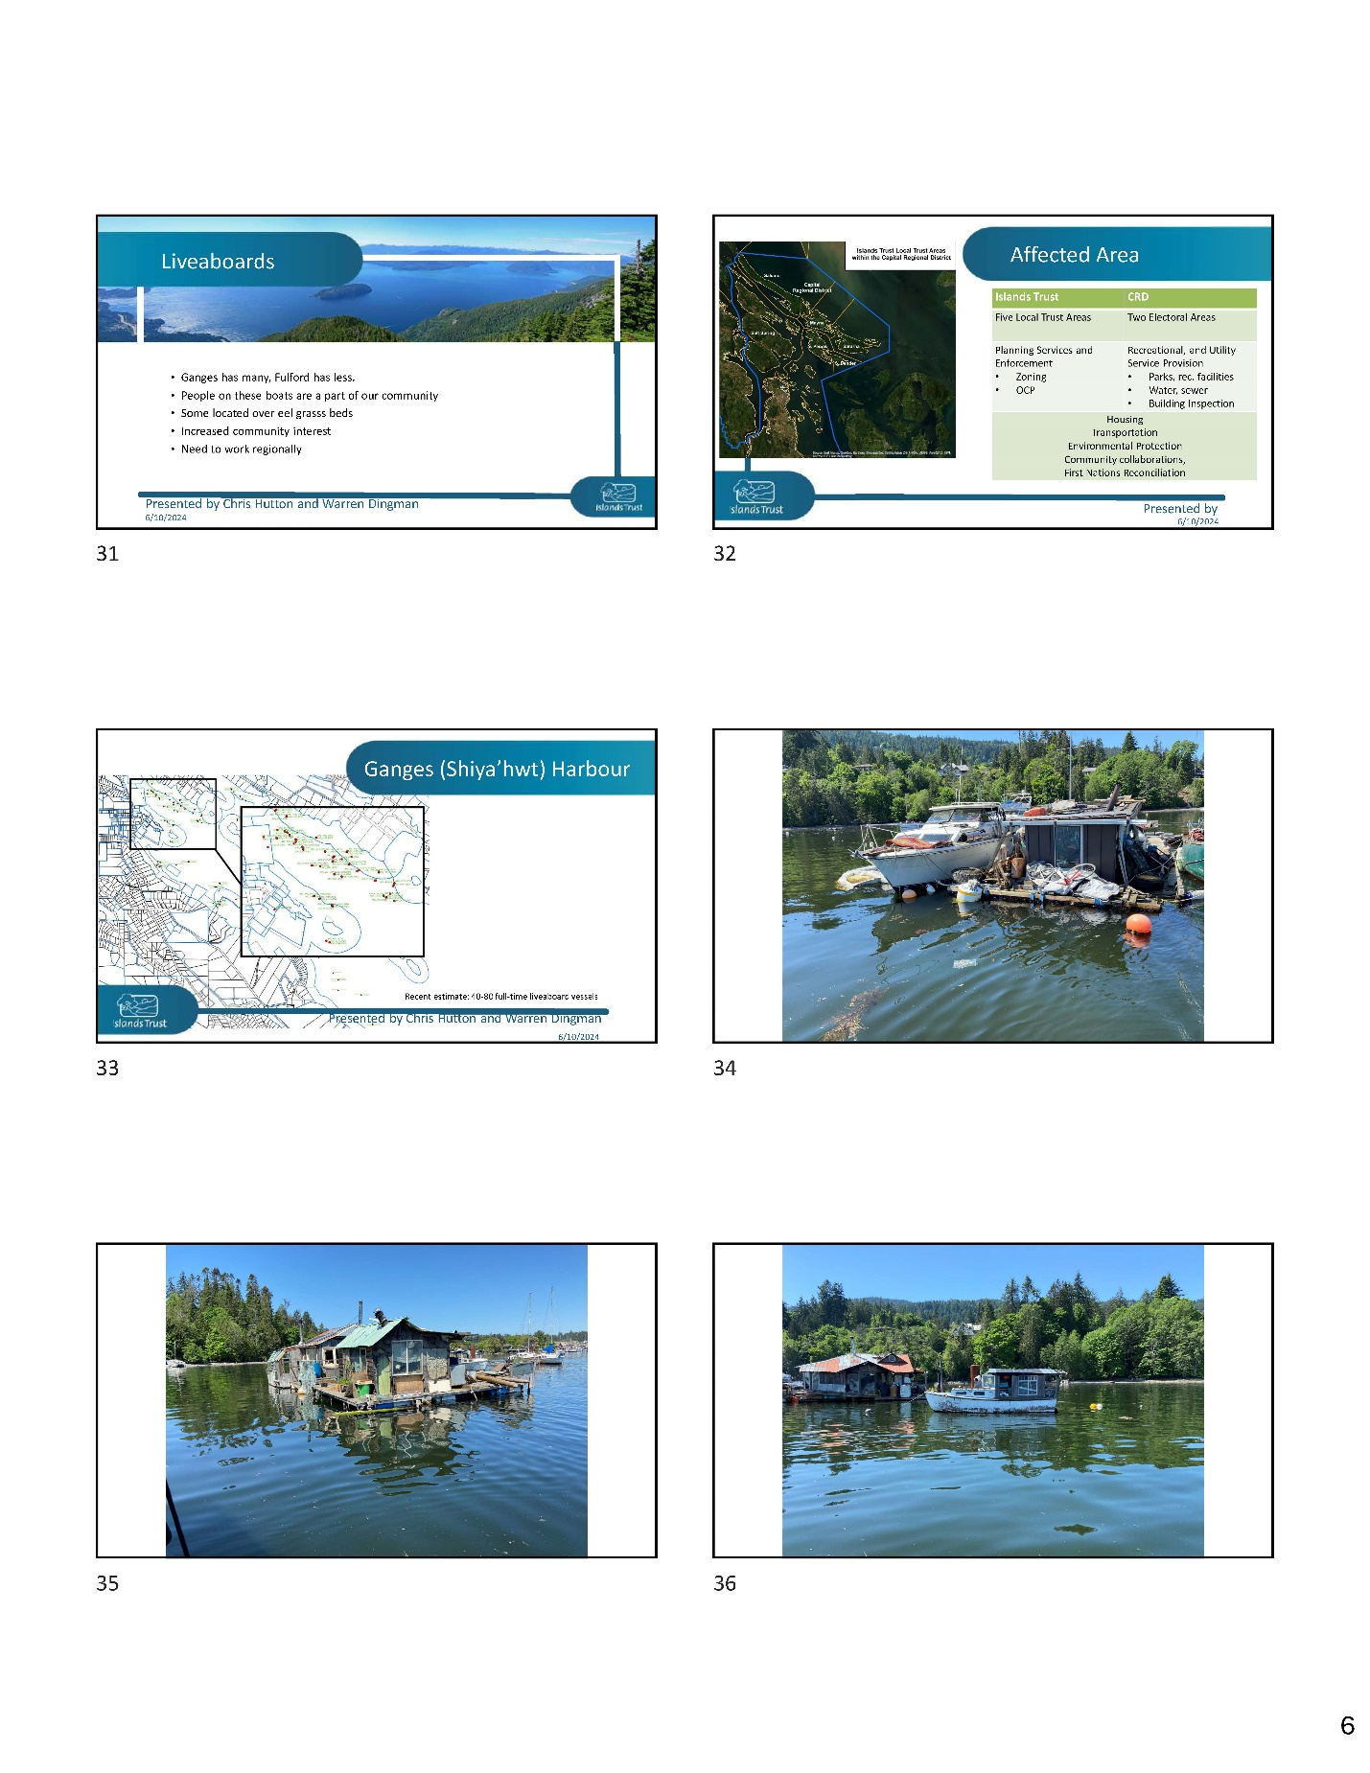
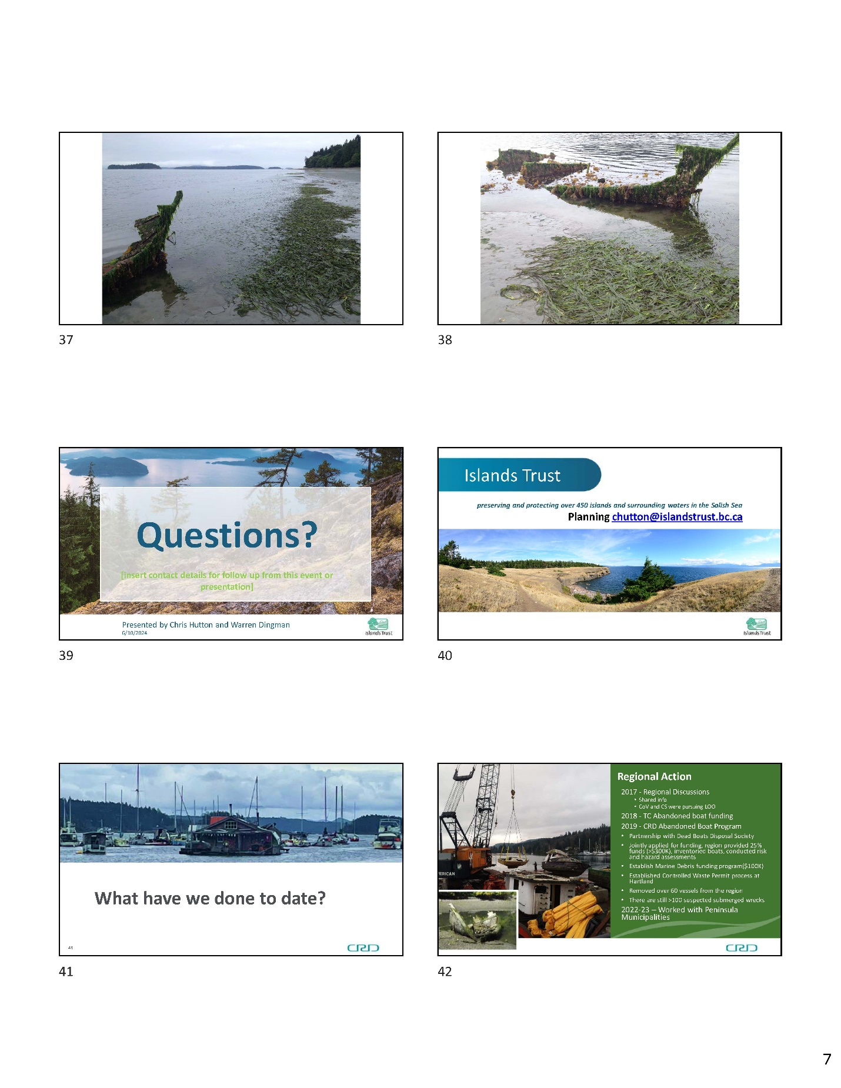
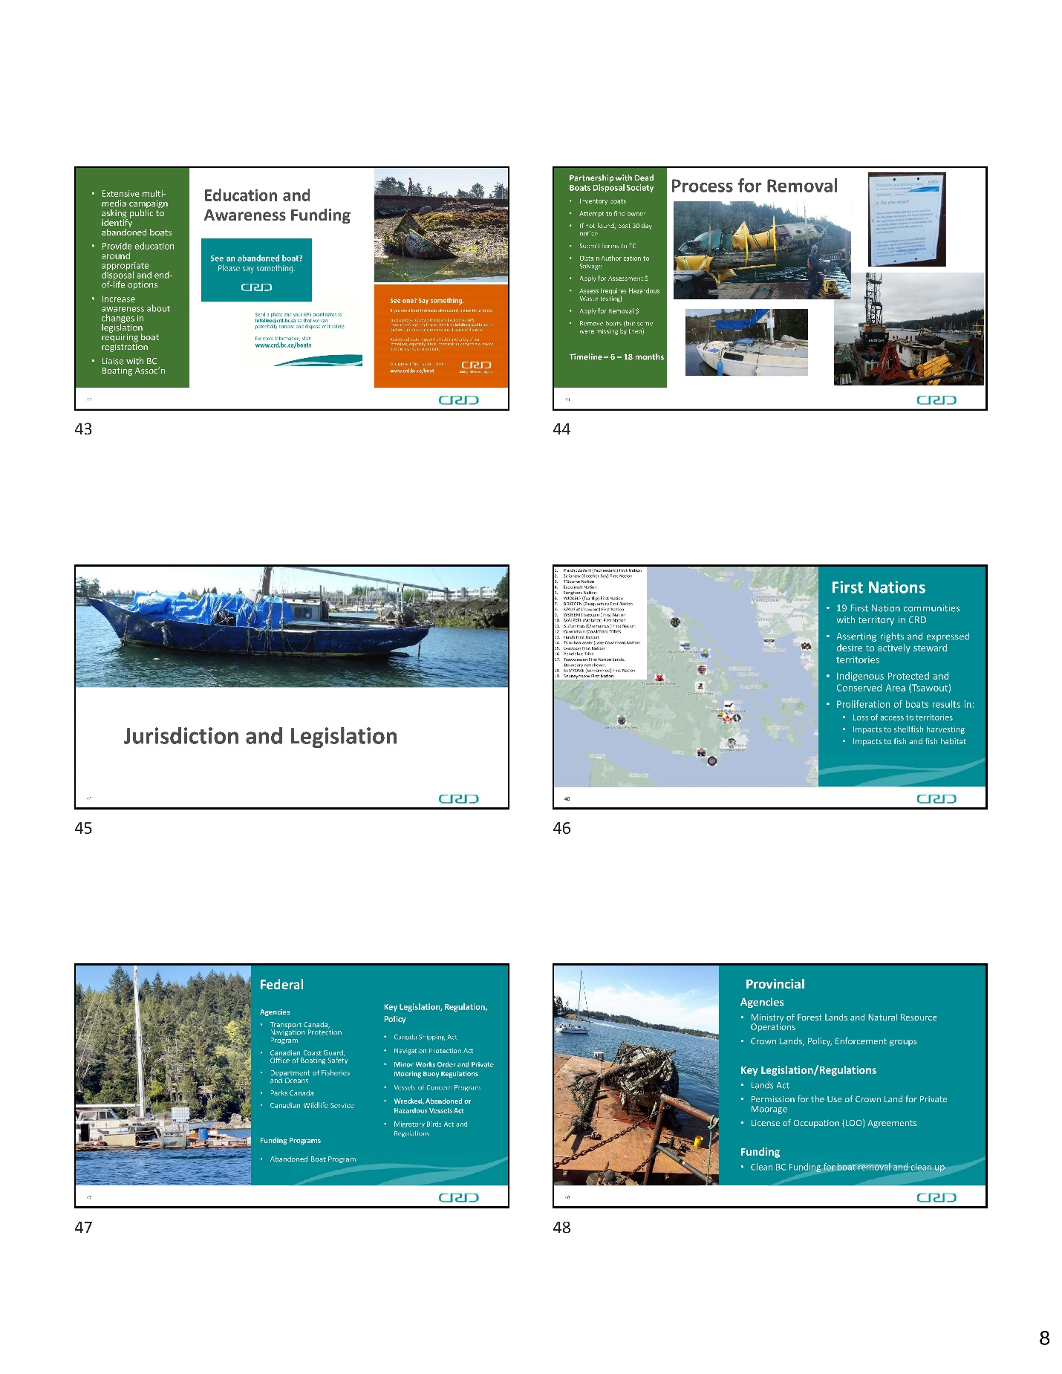
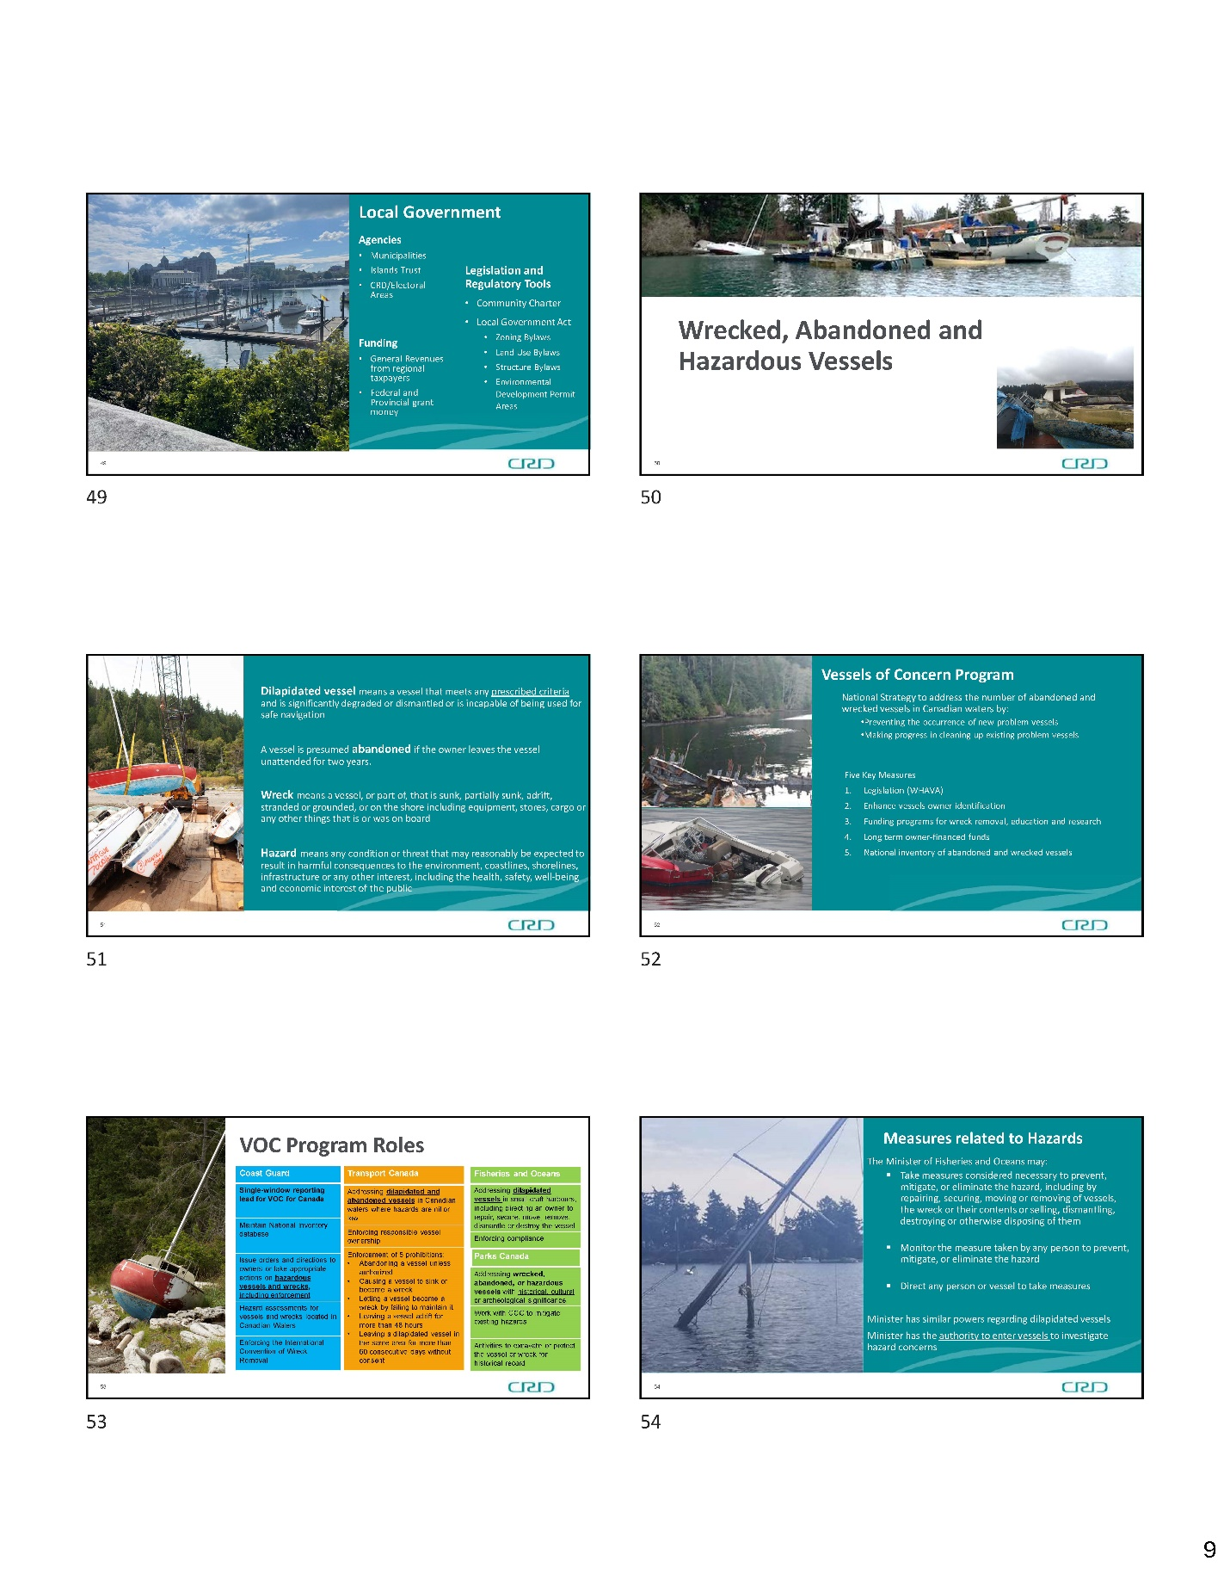
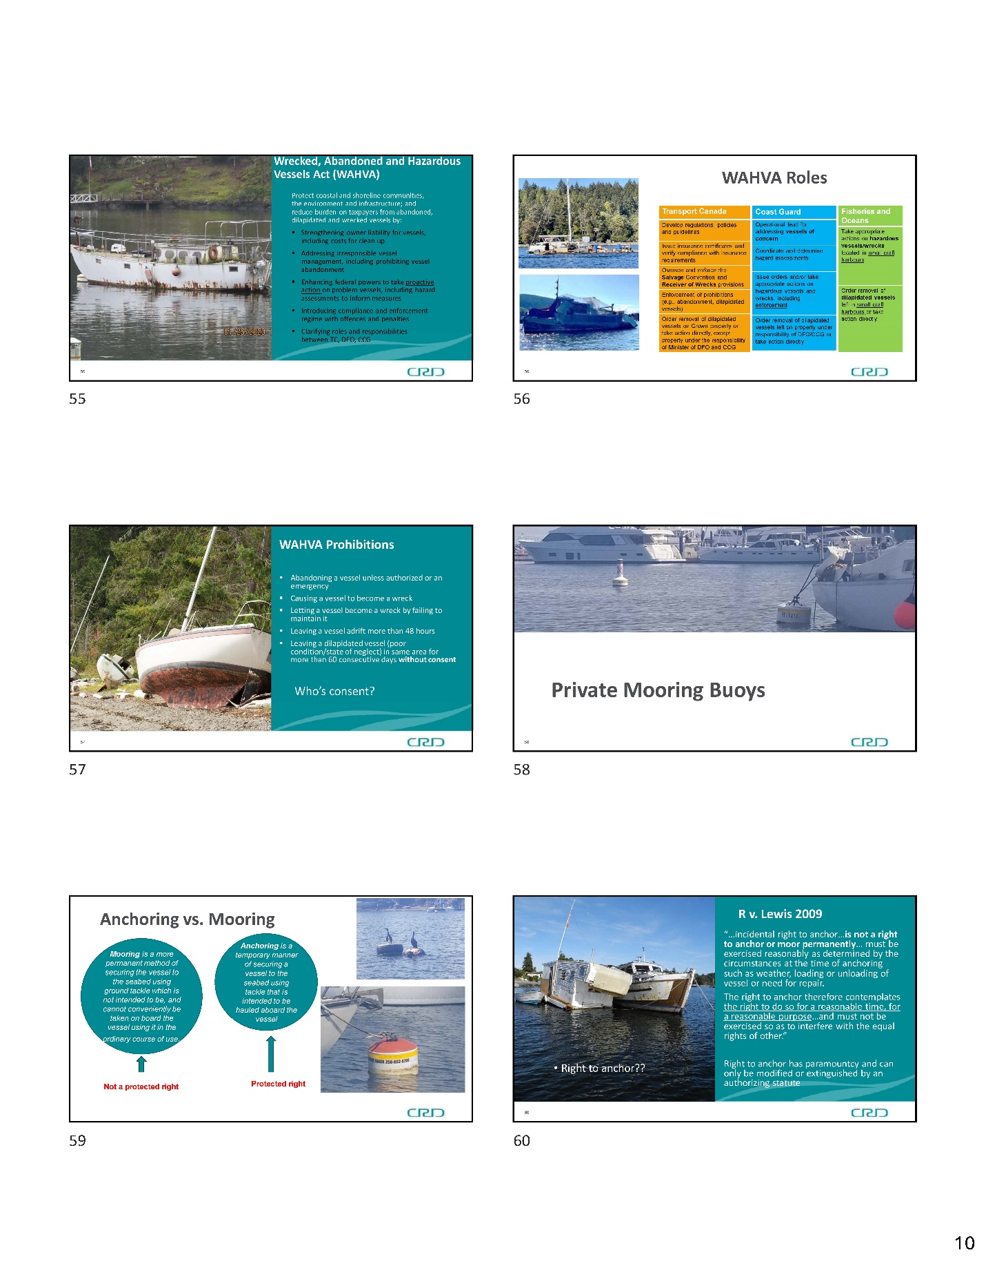
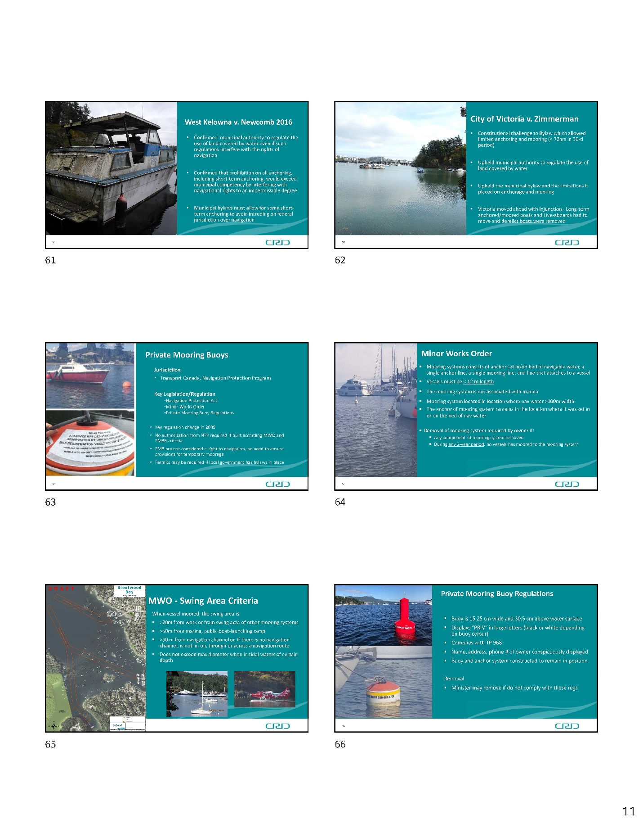
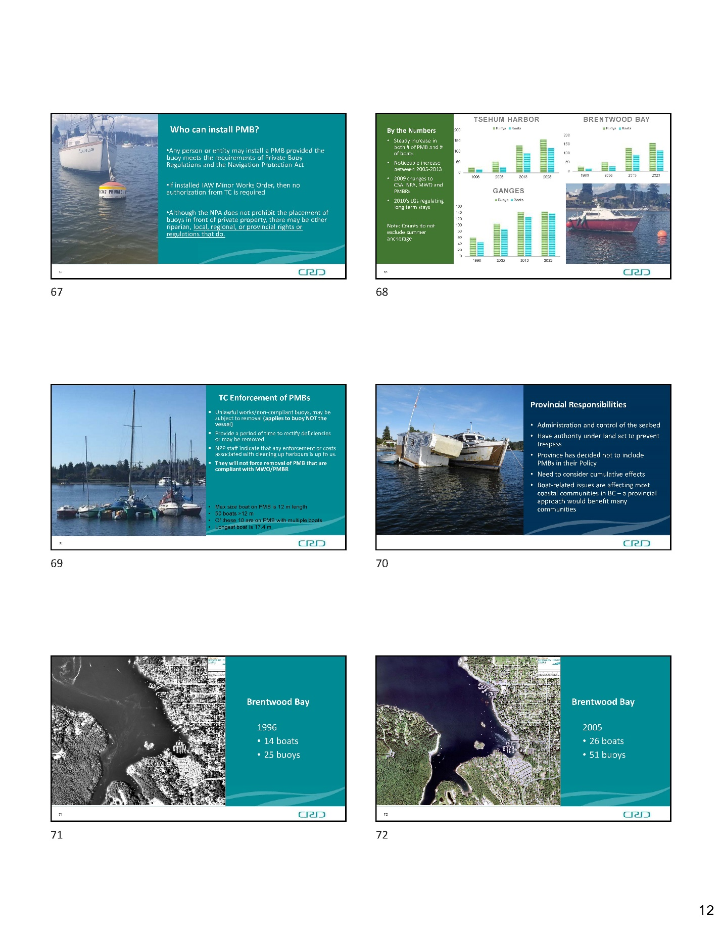
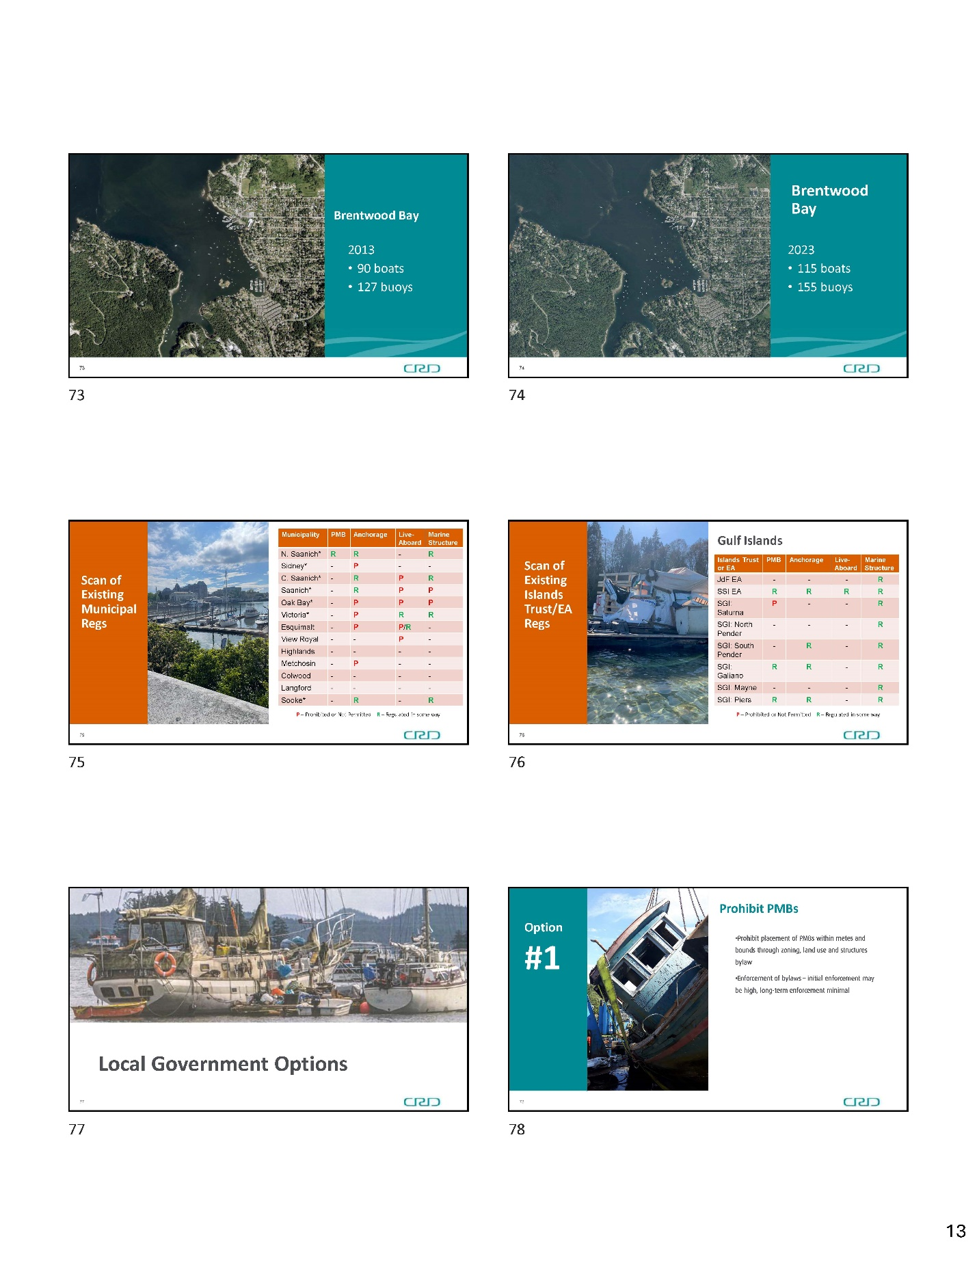
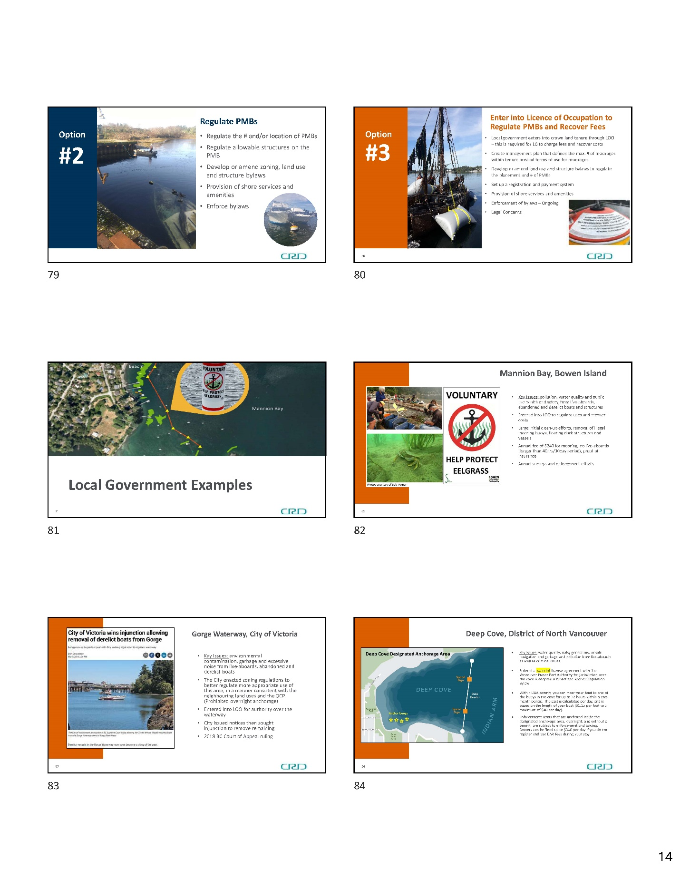
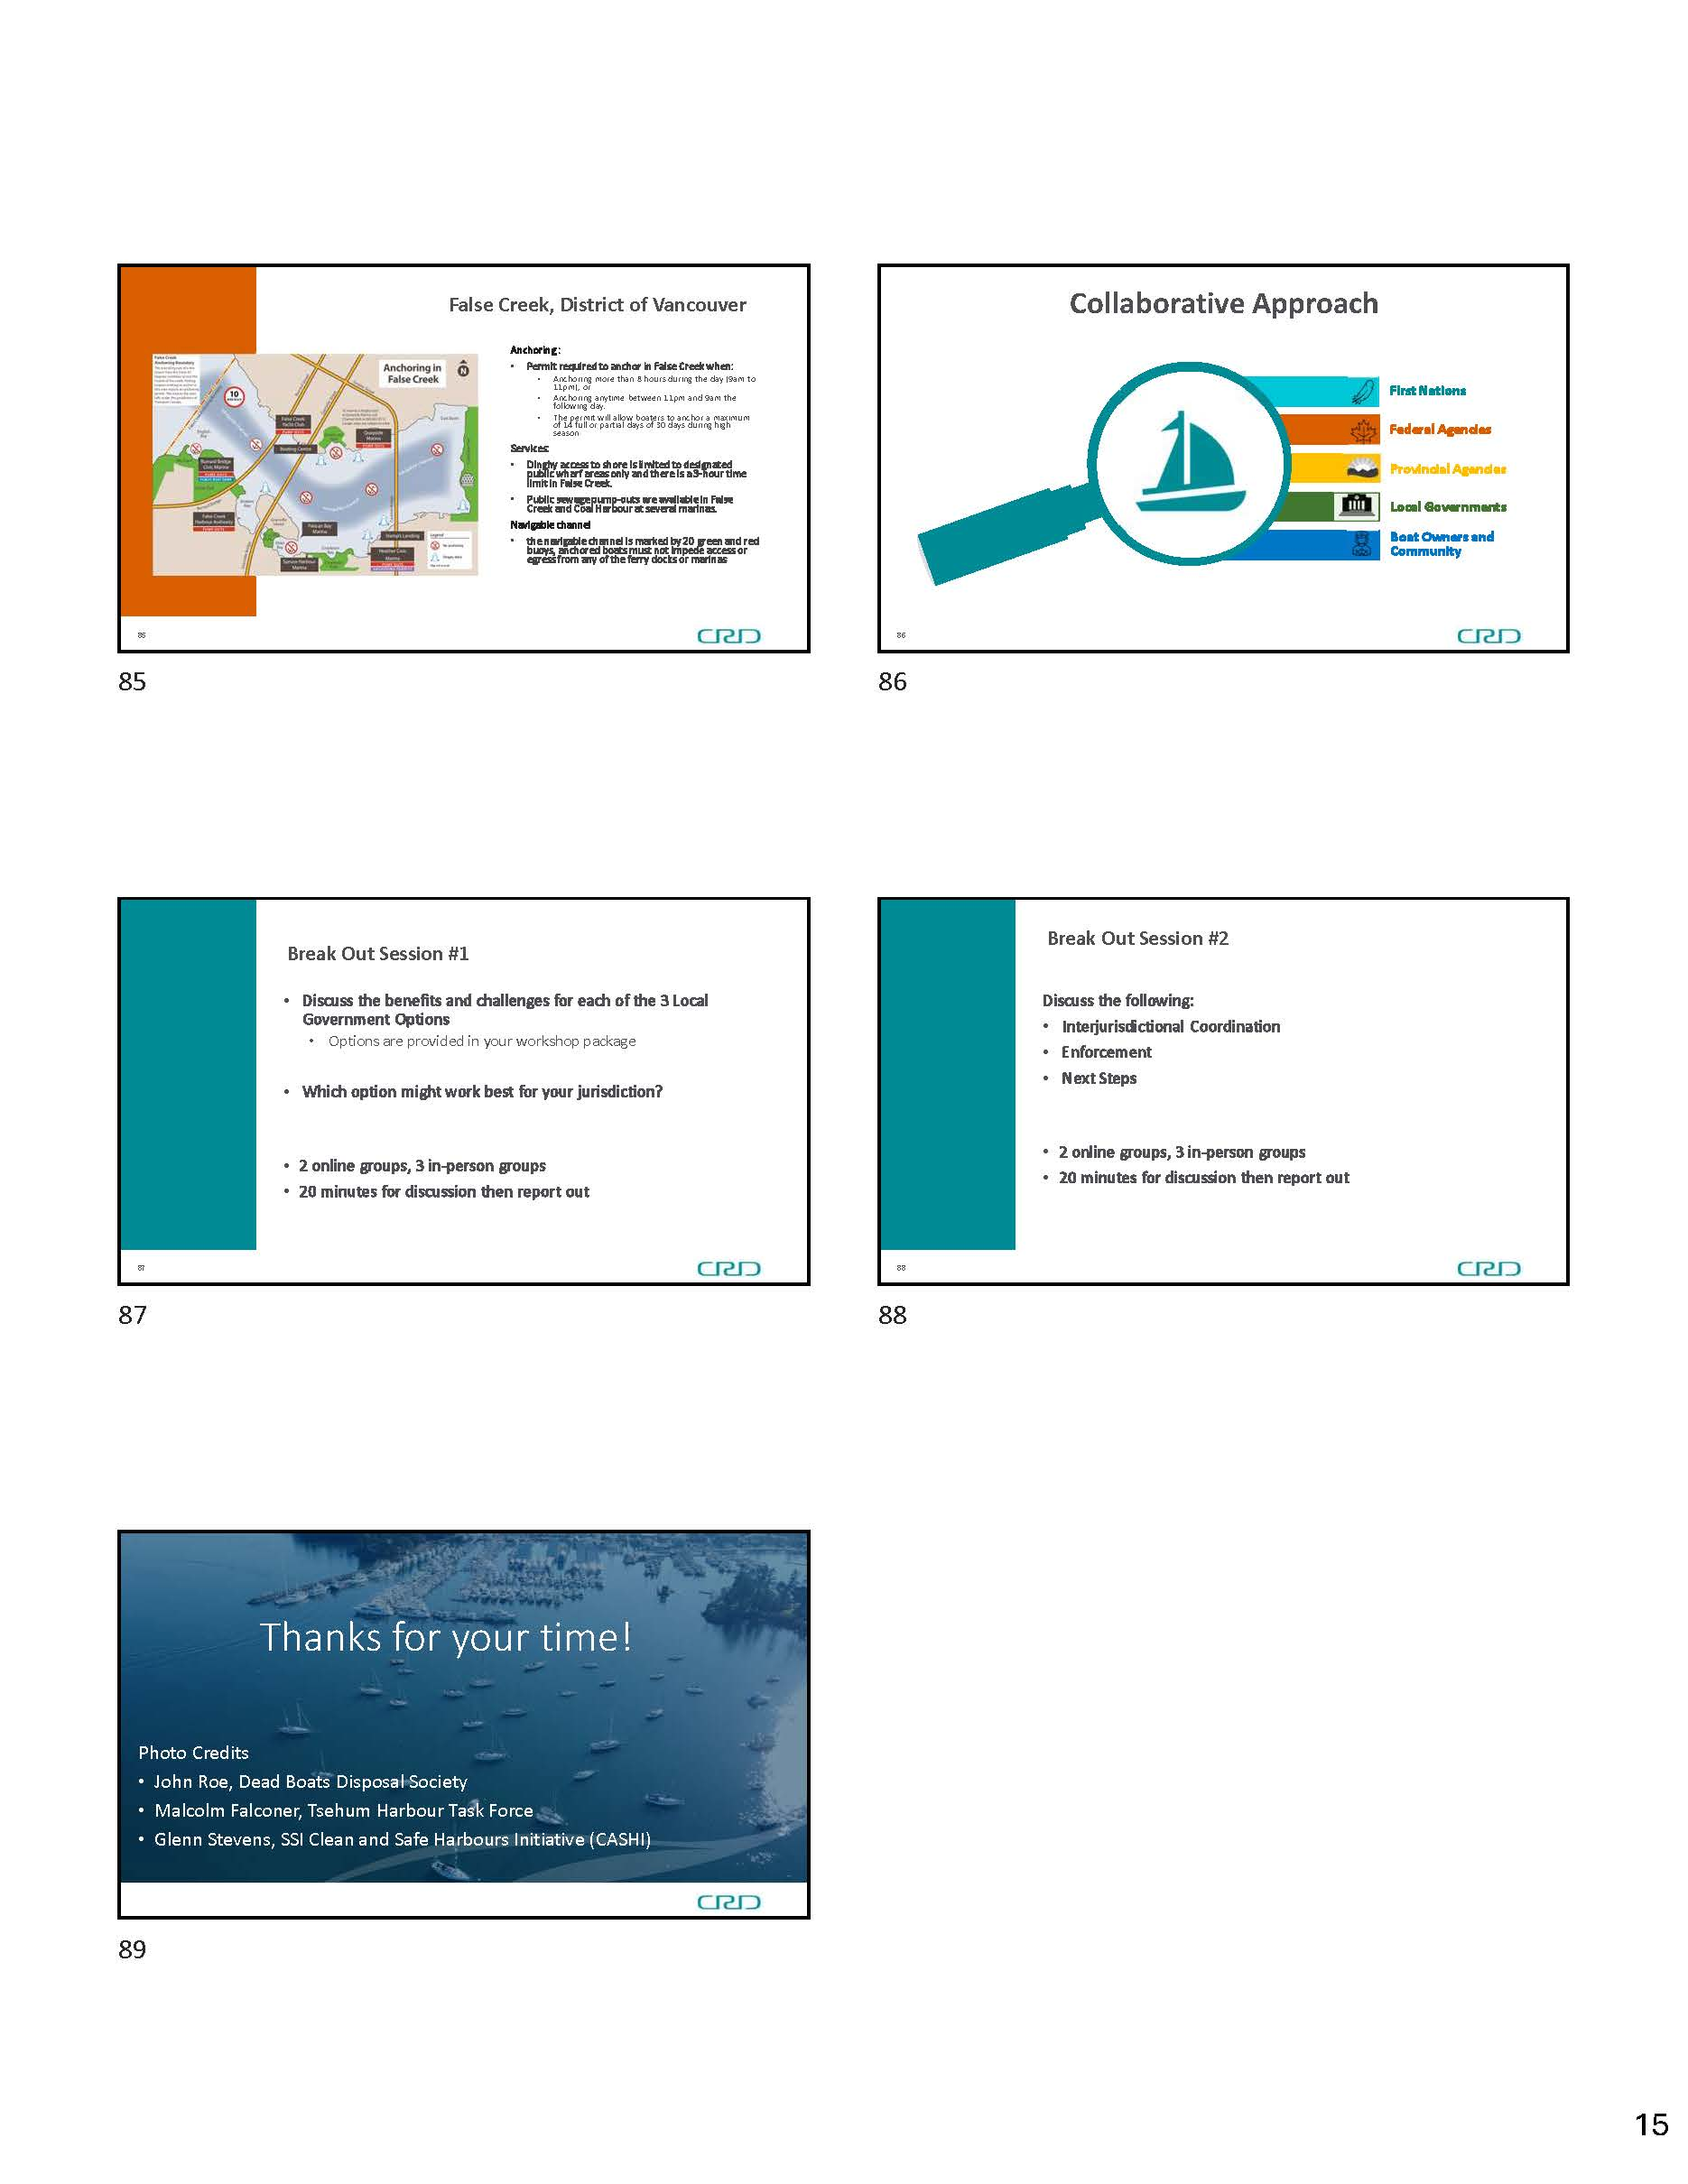

Appendix C – April 30, 2024 Meeting Notes

Option 1 - Prohibit PMBs through Zoning, Land Use and Structure Bylaws
Challenges | Benefits
Housing:  For certain harbours (i.e. Salt Spring Island, Tsehum) boats are one of very few housing options  - Liveaboards are living and/or working in the community - housing shortage is severe  (eg: hospital workers)  - Removes available housing “stock” on the Gulf Islands  - Anchoring (as the alternative to mooring) is more damaging to the sea bed and PMB regulation could result in an increase in anchored boats.  Infrastructure:  - Dock maintenance and moorings are full so would need to be expanded  - Moves the problem somewhere else  - Marinas are full - no dock space available  for moored boats to move to  - Would existing PMBs need to be grandfathered in?  - If banned, where can boats moor? Will they just keep moving around the region?  - Many of the structures are not boats, they are barges, wooden docks tied together, logs and boards, some are commercial barges that do not match their intended use  Public Perception:  - Not PMBs, it’s the actions of boaters when tied up that are issues  - Bad option  - Explosive, politically dangerous  - Does not solve the foundational issue  - Drastic move – negative feedback from community and bad press  Enforcement:  - Need a boat  - Opportunities for partnership  - Identification of ownership  - Complicated  - Capacity issues  - What and who does it?  - Rely on RCMP  - Lack of resources  - Need more enforcement dollars  Legal Challenges:  - Liability – what if there are existing PMBs there?  - First Nations Section 35 rights | - Local government can use familiar tools  (land use and zoning)  - Establishes legal authority for municipalities to do something  - Helps to protect key features  - Improved coastal stewardship  - Positive for environmental protection  - Reduces sewage discharge  - Allows protection of habitat and cultural sites  - Need to prohibit PMBs in cultural and environmental areas  - Appropriate in some areas  - Quick and easy reporting (public)  - People living in floating communities are not paying taxes  - Easier to enforce  - Equal “neat and tidy” for all  - Streamlines who is in charge

Option 2 - Regulate PMBs through Zoning, Land Use and Structure Bylaws
Challenges | Benefits
- Impact to individuals, particularly those that use vessels as housing  - Housing displacement (especially in Ganges)  - Complexity of service provision, jurisdictional authority  - Not a coast-wide solution  - Politically and morally challenging  - Needs the support of other jurisdictions (partnership), examples include:  - Indigenous Management Board (WASANEC to Nanaimo)  - Collaboration with CRD/Islands Trust  - National Conservation Protection area – transferring control of seabed to First Nations?  - Enforcement should include education (multiple visits?)  - Loopholes and adaptability of owners  - Cost of enforcement/enforcement capacity is even greater than in Option 1  - Cost of service provision, program, removal  - Time (staff) and willingness of staff  - How to monitor? Camera services if no fees?  - Supportive services – no resources at local government level to provide these services:  - garbage  - sewage (many areas do not have pump out facilities)  - access to showers  - can fees be charged for the supportive services?  - Legal consideration/legal challenges  - Structure bylaws could affect many of the existing structures that are cobbled together  - Grandfathering? | - Environmental – reduce overcrowding, dumping, intertidal crowding  - Encompasses diversity between harbours/boater communities - reflect the local community needs  - Creates areas of protection and allows boats (balancing needs)  - More consultation and collaboration with community  - Increase safety from current situation  - Could eliminate some “junk”  - Increase shoreline access  - Less social conflict  - Compromise, ‘more palatable to all’  - Way to demonstrate responsible boat ownership discussions around a Harbour Authority  - Regulation might reduce need for supportive services  - Less liability than Option 3  - Less liability if charged a permit fee?

Option 3 - Enter into a Licence of Occupation (LOO) with the Province to Regulate PMBs and Recover Fees
- Requires agreement with crown for land tenure
- Requires development or amendment of bylaws to determine placement/number, etc.
- Requires enforcement
- Requires supportive services (garbage, sewage, dinghy dock)

Challenges | Benefits
Liability:  - Contamination  - Land occupier  - Liability for unknown risks  - LOO – downloads everything to local government (less flexible than zoning)  - Financial – who pays?  - Similar funding/infrastructure challenges to Option 2, with addition of administration  - Can charge fees but will they be high enough to recover full costs of implementation?  Enforcement:  - More challenging  - Acting as private owner  - Lack of capacity for enforcement, would need more capacity to manage this  - Similar challenges to Option 2  - Public perception: seen as an elitist way to achieve Option 1  - Violates First Nations rights and titles  - On Gulf Islands who would take out the LOO – CRD or Islands Trust?  - Administration/capacity at local government level an issue  - Need to advocate to Province  - Greater demand for services if charging  - Not much more useful | - No non-conforming issue  - Can have LOO and zoning  - User pay system – provide revenue to offset costs (this is more fair for the users to pay for the services)  - Purpose of going this route is local governments cannot afford to provide the services  - Similar environmental benefits to Option 2 mooring is less damaging to the environment than anchoring  - Evidence based research and approach  - First Nations consultation increased

Next Steps
First Nations
- Collaboration with First Nations (FN)
- FN role – partnerships
- Indigenous Management Board - 11 Nations
- Talk to FN boards/councils for direct input
- Indigenous Management board role
Collaboration
- Need collaboration = consensus on this and resources
- Next steps – task force or working group?
- Whole coast collaboration
- Need for funding – where does the money come from?
- National Marine Conservation Area
- Deregulation issue
- Collaboration and advocacy with federal and provincial governments

Housing
- Fundamental housing problem is a big issue affecting the Gulf Islands
- Need to learn more about people living on boats
- Know more about people living on boats
- Saanich Inlet Protection Society (SIPS) + liveaboard groups – commonality
Roles
- What are the roles towards a solution to this issue?
- Role of vacation moorage(s)
- Get decision makers together to resolve this
- Need to engage with community
Resources/Funds
- Capacity challenge for all
- Enforcement issue – highly complex, lack of decision makers, who has jurisdiction?
Advocacy
- Consideration of coordinated approach for advocacy – all
- What federal plans are coming?
- Marine Protected Area regulation change
- Cumulative impacts of PMBs
- ADM Mack, Assistant Deputy Minister, talked about the BC Coastal Marine Strategy – BC government developing high level tool kit and partnerships
- Data compelling – in terms of the rate of change
- Need for all to commit resources and do the work SOON
- Focus on problem areas - do trial program there first and learn
- “Sunset of Salish Sea” report – sustainability
How to move towards collaboration?
- Proper inventory
- Existing violations addressed
- Task force or working groups? How to formulate, how to fund? The Province can help get the right decision makers engaged. NOTE challenges – wildfire season is here, election year
- Coastal Marine Strategy flags this boat issue
- CRD has given input, will give more
- All local governments should review and give comments
CRD Next Steps
- Staff report to CRD board – suggest a working group
- Role of CRD – Saanich Peninsula Harbours Service now suspended by Central Saanich
- Ocean Protection Plan – Transport Canada
- Funding increase through Coastal Marine Strategy
- Next Step - Elizabeth May’s office can help connect ministers and bridge concerns
- Success of derelict boat removal so far. Keep at it!
- Importance of relationship with community and leadership
- Rebuild trust, individual relationships
- Other places in BC and Canada. Are PMBs an issue on the East Coast or the Great Lakes?
Meet with Indigenous Management Board
- Coastal Marine Strategy - share CRD submission and invite board input - not enough time for that.
Parking Lot Items
- Boat buy-back programs
- Need better data
- Need to have a one stop shop - there is currently no group that you can talk with about this, there are multiple different agencies, very complex and confusing
- FN Port Authority
- FN input needed
  - Challenging to consult
  - Capacity at Nations an issue for consultation, need funding
  - Ongoing unresolved claims
  - How to unwind this system
  - Haven’t been part of the process
  - Process – lack of FN options/conservation(?)
  - Missing part of the solution
- Context has now changed
- Housing alternatives roll out over next 10 years
- Capacity
- Consider interim task force to try to solve this issue: Fisheries and Oceans Canada (DFO), Transport Canada, Canadian Coast Guard, BC government
- Proposed Conservation Values/Marine Conservation Area
- underlying issues for Salt Spring Island
  - “class conflict”
  - Local decision making
  - FN Decision Making and Control/Governance/Stewardship and Collaboration

